It’s Razor Thin
By Perry Jones, Piney Wood Model A Ford Club

When I think about shaving during the Model A Era, I always think about straight razors (also known as cut throats), and a lathering cup and brush. This type of razor has been used for centuries for shaving and grooming, and it is still popular among many barbers and shaving enthusiasts today. But where did the straight razor come from, and who invented it?

The exact origins of the straight razor are unclear, but historians believe that the ancient Egyptians, Greeks, and Romans all used similar types of razors for shaving. However, the modern straight razor as we know it today was first developed in Sheffield, England, during the 18th century.
The first known maker of straight razors in Sheffield was Benjamin Huntsman, a cutler who developed a new method of producing high-quality steel known as crucible steel. Huntsman's crucible steel was strong, durable, and easy to sharpen with a leather strop (pronounced sträp), making it ideal for use in straight razors.
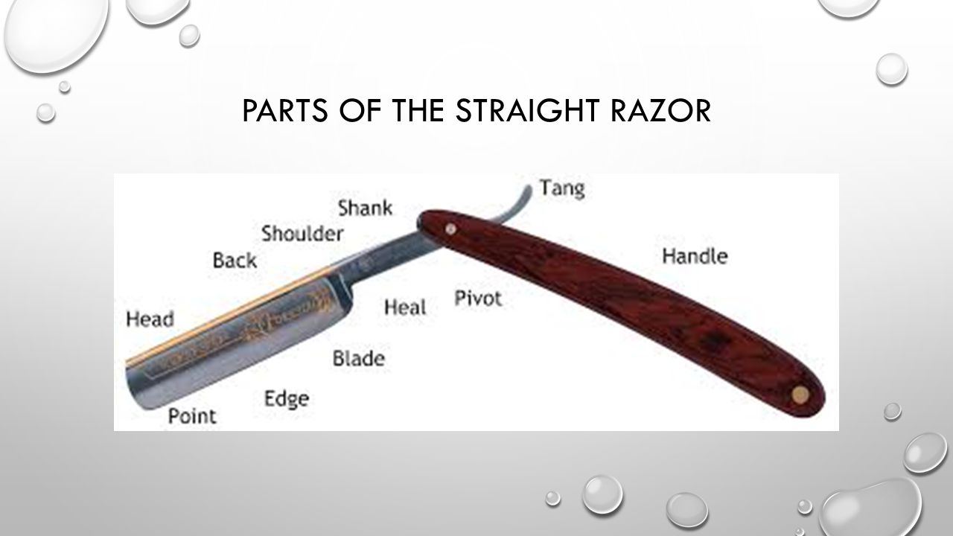
Anatomy of a Straight Razor

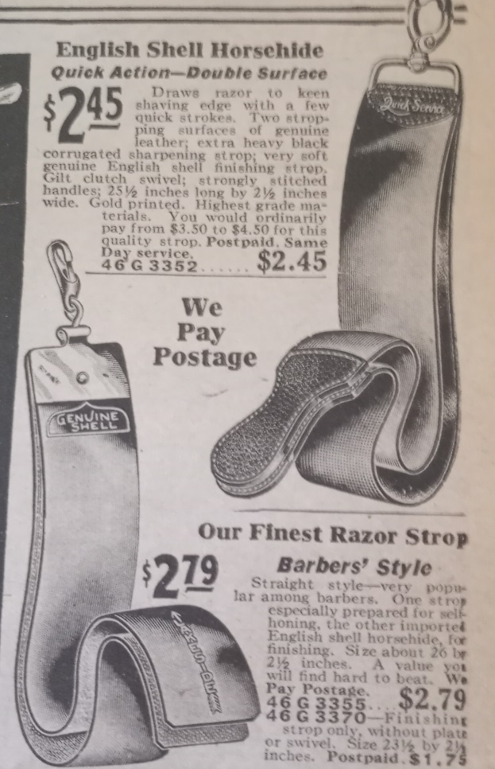
Huntsman's straight razors quickly became popular among barbers and gentlemen alike, and the demand for his razors grew rapidly. Other cutlers in Sheffield soon began producing their own straight razors, and by the early 19th century, Sheffield had become the center of the world's straight razor industry.

The images below and to the left are from Montgomery Ward Fall/Winter 1929-30 catalogue.

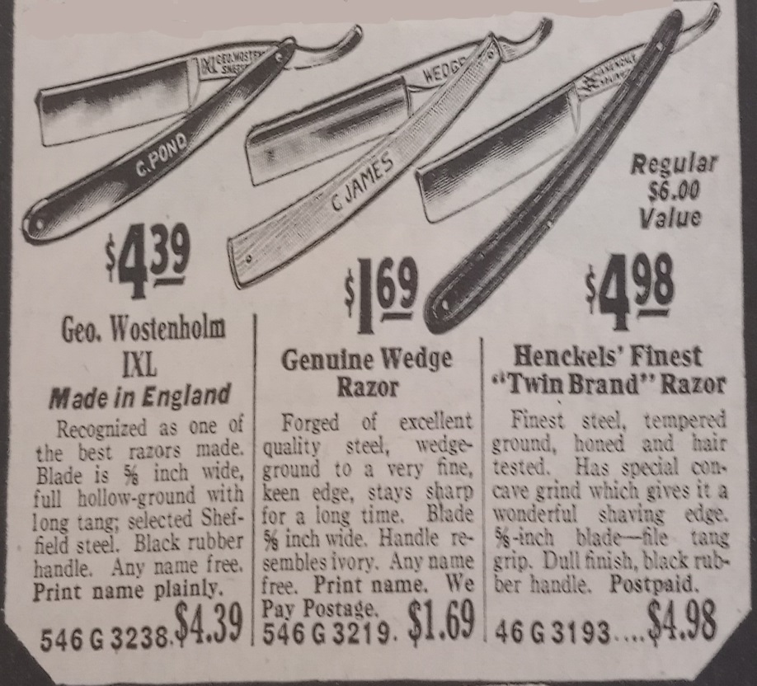
Leather Strop
Despite the invention of the safety razor, the straight razor remained popular among barbers and shaving enthusiasts throughout the 20th century. Today, many barbers and shavers still prefer to use a straight razor for its precision and control.

In 1903, King Camp Gillette (shown left), an American Entrepreneur, introduced the world's first system razor—a two-piece safety razor with a thin, strong, sharp double-edge blade attached to a reusable handle. When the Gillette system razor hit the market, it didn't take long for blade sales to reach into the millions.
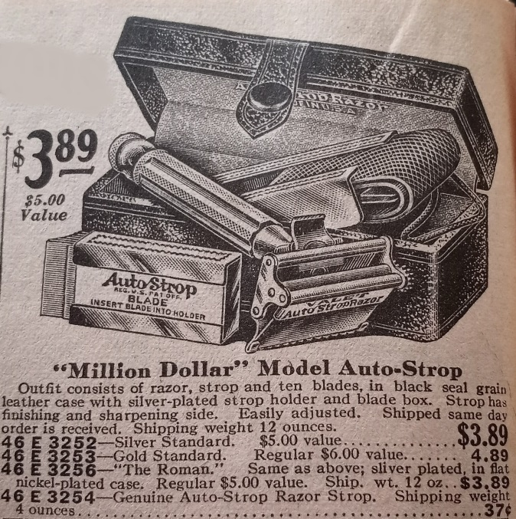
Safety razors of the Model A era typically used a double sided blade and when they became dull they were replaced with a new blade. The Valet Auto-strop was different in that you could strop the blade while the razor was still in the razor head. The Auto-strop Safety Razor Company, Inc., or Auto Strop, was founded on April 27, 1906 by Henry J. Gaisman, R. E. Dwight, H. K. Stockton and Henry Audley in New York City. Its industry was shaving products and its headquarters remained in New York. In 1927, the holding company Auto-strop Corporation was merged into its Auto-strop Safety Razor subsidiary. It was acquired by the Gillette Safety Razor Company in 1930. Gillette continued manufacturing Auto Strop razors until 1946, and Auto Strop razor blades until the 1950s.
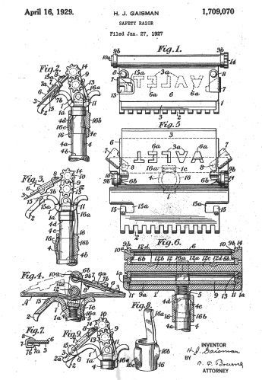
Valet Auto Strop Patent granted April 16, 1929

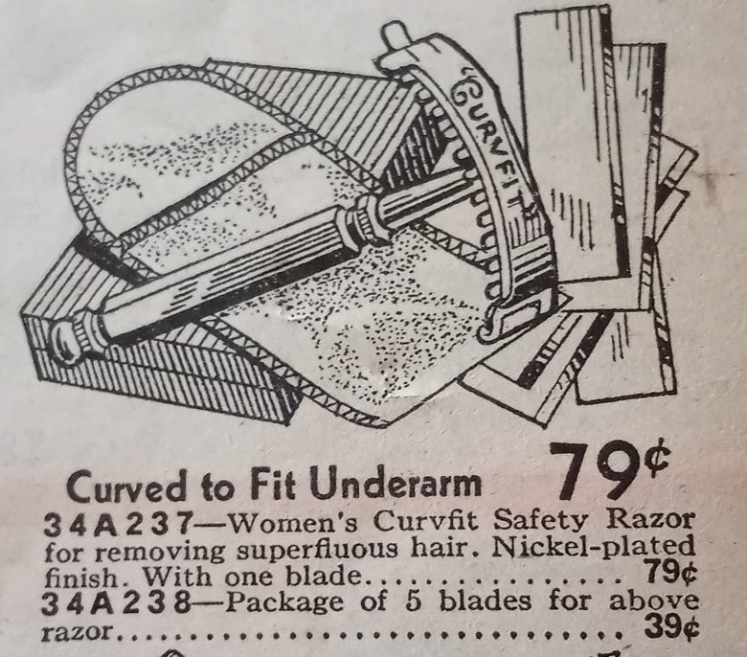
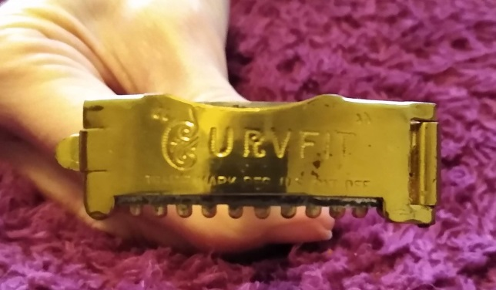
Let’s not forget the ladies. This vintage hand razor was manufactured by the Curvfit Razor Company of New York City. The patent for the design was issued in 1913 and became a retail product in 1924. The razor had some popularity and was on the market until 1945. The razor design incorporated a flexible blade which allowed the razor to follow the contour of the razor head.

Shaving tools are quite common in Antique stores as well Etsy or EBay, so finding a razor to add to your collection of fashion accessories would be very easy to do. Happy hunting.

References:

Montgomery Ward & Co. Fall & Winter 1929-30
National Bellas Hess Co. Fall & Winter 1930-31
Wikipedia
Mycompanies Wiki
U.S. Patent Office
Personal Collection

#######

