Spring 1931—It’s Lines, Not Styles!
Advice for Men from one of New York’s Oldest Tailor Houses
By Peggy Gill, Sacramento Capitol A’s
“The wary male has reached that utopian state where the less he thinks about style per se the better dressed he is likely to be.”
--Dorothy Budd, Women’s Home Companion, March 1931

Spring is just around the corner. Snow may be melting and sprigs of new growth are beginning to burst out all around us…everything is looking fresh! Your wardrobe may need refreshing too, so let’s break out from the dreary winter and shed that cocoon into a new you! Many women get this…and are off to their favorite shops to brighten up their wardrobe as the weather warms and we begin to spend more time outdoors or gathering with friends. Each new season brings to light new styles, new fabrics, or new colors in the world of women’s fashion, but for men, the changes are not so obvious. In the Spring of 1931, it was all about lines—not styles.
Unlike women’s fashions that seem to change with each season, men’s fashions tend to stay basically the same year in and year out. In an article found in the March 1931 issue of Women’s Home Companion, author Dorothy Budd states that “the stark truth about men’s styles for spring seems to boil down to just this—there aren’t any.” She based her startling declaration on an interview with a representative from Wetzel, which was one of the oldest men’s tailor houses in New York at the time. The Wetzel representative went on to clarify, “Every five years or so you can note a subtle difference in the cut of a jacket or the roll of a lapel—a difference that will hold its own for the next five years and then give way to another” slight change. For the average man, those fashion changes are not worth the trouble to upgrade their wardrobe. In fact, it was suggested that a man would be better suited “to find out which style of suit best sets off his figure then stick to it” regardless of the “minor permutations” put out by the fashion houses.
It’s wise to choose a suit with the right lines for your figure.

What follows are suggestions from Wetzel’s representative:
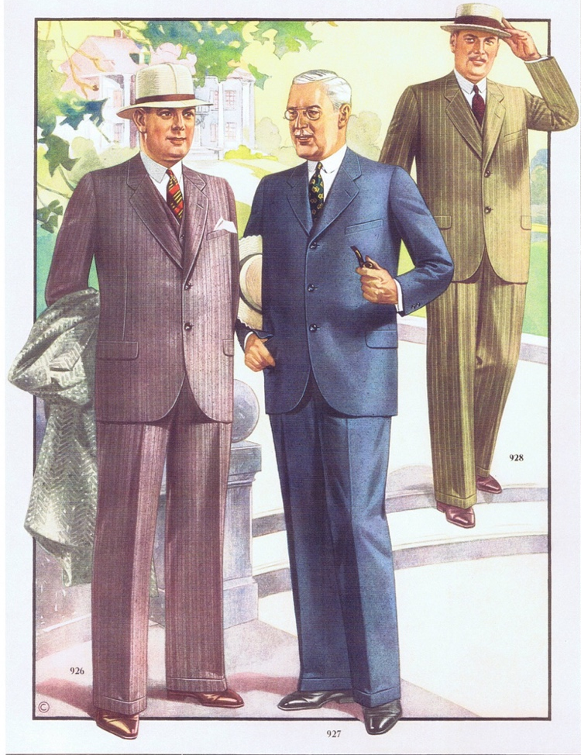
For the man who is short and stout, “look for vertical effects wherever possible. A single-breasted jacket is better for him than a double-breasted one. The lapels should be long and narrow, the waist straight, and the shoulders well-fitted with no hint of padding. To give an added illusion of height and slenderness, the trousers might taper a bit from the calf in toward the ankle.”
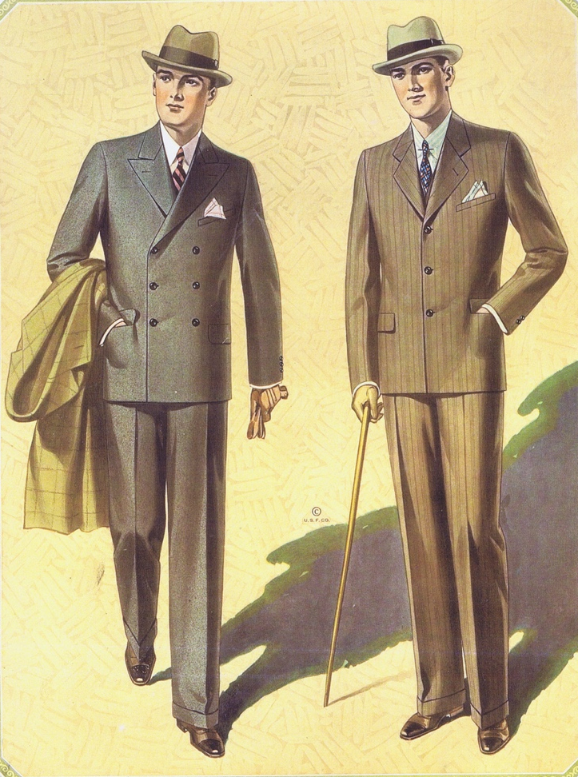
When asked for suggestions for that long and lanky man, the reply was that “he must strive for lateral lines—a double breasted jacket rather than a single-breasted, a natural shoulder with the chest well worked out (full chests are always more effective than padded shoulders), a slight fit at the waistline, and a trouser leg sufficiently wide at the bottom to break the long line of the shoe.” It should be noted that the “lateral lines” mentioned above refer to style lines, not lines of color or pinstripes in the fabric.
It is also important to consider the fabric texture of the suit. For the thin man, “those fabrics with a surface nap—cheviots and home-spun—give a becoming suggestion of bulk.” For the stout man, “smooth clear-finished worsteds are best—fabrics that do not stretch easily and give no impression of width.”
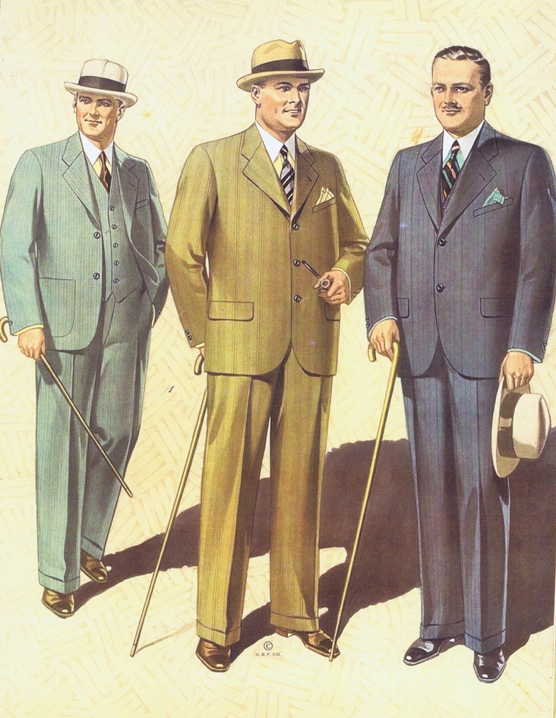
Not to be ignored, color also plays a part in the overall effect in menswear. An overweight man should “stay away from patterned materials.” For him, according to Wetzel, “plain dark fabrics are the only practical choice.” The one exception is for the short stout man—"he may wear a conservative stripe” because this adds an illusion of height to his overall look. On the other hand, we are told the tall thin man should always avoid stripes, but when it comes to color, both lighter and darker shades are fine.
If you are not short and stout, or long and lanky, what style works for you? According to Wetzel’s representative, the “well-proportioned man” has the option of virtually any style and color he chooses. His main concern is to keep away from extremes. “Patterns that are not too marked, suits unobtrusively cut, plain shirts, conservative socks and ties—these are the only style essentials for a man.” As to color, it was suggested that “men keep to the combinations nature has used.”
You may be asking yourself where you fall in your quest for that new suit you have been thinking about. If you don’t fit the 1931 ideal of “the well-proportioned man” noted above, this basic table may help sum it up:
 | Short & Stout | Long & Lanky | Overweight
Suit Jacket | Single breasted jacket  Long and narrow lapels  Shoulders well fitted  No hint of shoulder padding  Straight waist | Double breasted jacket  Narrow lapels  Natural shoulder  Padded chest to make it look fuller  Slight fit at the waistline
Pant Leg Style | Tapered slightly from calf to ankle | Wider trouser leg to break the line of the shoe
Fabric | Smooth finish | Fabric with texture or a surface nap
Things to Avoid | Stretchy fabrics | Stripes | Patterns
Things to Consider | Conservative vertical stripe | Lighter shades as well as darker colors | Plain dark colors

The last bit of advice offered by Wetzel’s Tailor House is as valid today as it was in 1931. Basically, men should buy smart and consider lines appropriate for their shape, not necessarily the latest style of the day.
Sources:
Budd, Dorothy. “Lines, Not Styles.” Women’s Home Companion, March 1931, p. 114.
MAFCA “Stepping Out in Style,” CD. Bond Street Styles, Spring/Summer 1930, pp. 15, 28, 30.

# # # # # # #

