Stepping Out in Style: Distinguishing the Model “A” Era Lady’s Shoe Heel

*By Lynda Davis, Dallas and Fort Worth Model A Clubs*

Now more than ever, Model A era reproduction shoes for ladies are readily available at our favorite stores. Nostalgic fashion modes arose after a series of Depression-era films, such as *The Artist* (2011), *The Great Gatsby* (2013), *Boardwalk Empire* (2010-2014), and *Downton Abbey* (2010-2015), encouraged a new generation of vintage fashion enthusiasts. In the wave of these films, access to reproduction wear increased. Retailers specializing in vintage fashions are popping up in the U.S. and Europe. Companies such as American Duchess (the images to the right, taken from their website, illustrates their historical accuracy), Miss L. Fire, and dance-shoe companies offer era-correct shoes. However, each era fashion enthusiast must do his or her own research to vet each fashion purchase. This article focuses on recognizing Model A era shoe heels and matching heel height to the complementary dress-hem length.

Many of us recognize the typical Ladies’ Model A era shoe; however, distinguishing the “competition worthy” heel may be more difficult. Modern ladies’ shoes may have “the look” of our era; however, the heel is not always accurate. For instance, the figure to the left shows a shoe currently available by a major manufacturer. Its tall, rectangular heel is significantly dissimilar to the Model A era heels illustrated in the below figure found in the *MAFCA Fashion Guidelines*. While the top portion of this pair conforms to the era’s T-Strap appearance, wearing them in a competitive venue will result in points lost. If you purchase a pair of modern shoes with an era look but without the era heel, wearing them for fun is always an option.

**A sampling of Model A era shoe heels provided by *MAFCA’s Fashion Guidelines***

While this article defines popular Model A era heels, distinguishing one style from another can be difficult. As the *MAFCA* *Fashion Guidelines* states*,* “[T]hough there were several types of heels, they are not always identified the same by different manufacturers” (3E2). Indeed, when researching primary sources from 1928-1931, one will often see the heel names used interchangeably. Knowing the proper names for heels is less important than recognizing their look. Therefore, to help Model A era fashion enthusiasts find period-correct shoes, this article covers the characteristics of some of the most popular shoe heels for women—such as the Cuban, Military, French / Louis, and Spike heels.

**Anatomy of the Model “A” Era Shoe**

**The Cuban Heel:**

Around the mid-1920s, the Cuban heel began to dominate ladies’ shoe fashion, surpassing the long-popular, hour-glass shaped Louis heel. By April 1927, the fashion magazine [*Vogue*](https://www.google.com/books/edition/Vogue/-4CyRjuL24AC?hl=en&gbpv=1) reports famed New York shoe designer A. J. Cammeyer’s plans to make Cuban heels “the key-note of his walking shoes.”

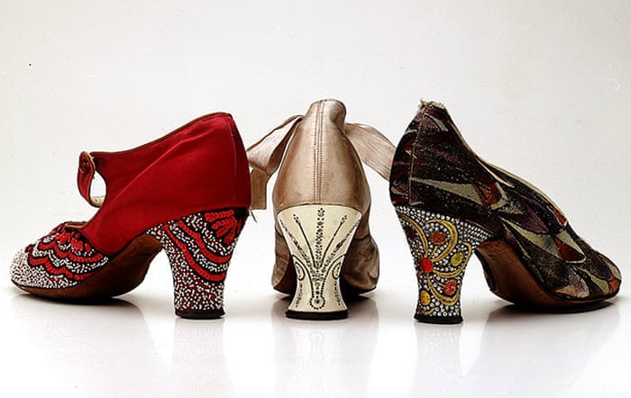Common in western wear, the Cuban’s square heel (usually made from stacked leather or wood, sometimes covered in material) has a straight front or breast. (See image “Anatomy of a Model “A” Era Shoe.) However, the backline slopes gradually—along with the sides—towards the heel’s cap. There is a bit of a curve that the Military heel lacks. This style makes the heel suitable for both work boots and dressy fashion shoes (Dyer 6). Indeed, *Vogue* reports that both Saks-Fifth Avenue and I. Miller planned to offer Cuban-heeled shoes in styles for both day and evening and in varying heights—Saks introduced two heights and I. Miller introduced three: low, “designed primarily for comfort”; medium, for walking; and a high-heel, which *Vogue* called a “dizzily high . . . heel that has been gaining ground.”

For evening wear, Cuban heels were often affixed extravagantly with “rhinestones, mock tortoiseshell or cloisonné enamel” (Cox, *Vintage Shoes* 31) (see the above image of three rhinestone heels. The Cuban is at the left, and Louis heels are center and right). One distinguishing feature of the Cuban is that oftentimes the heel is a “knock-on,” which means “the sole leather does not continue down the [shoe’s] breast, but rather the heel is constructed completely, then attached, with no further crafting” (*American Duchess*).

**The Military Heel:**

The Military heel, “built upon the Cuban design” (*The Shoe Retailer,* 77), is almost a twin to the Cuban. With straight sides and back line, it doesn’t taper like the Cuban does. While it throws the foot a little forward, it is more supportive because the surface area at the cap is larger than the Cuban. For these reasons, it is a popular heel for women’s walking and sport shoes, cowboy boots, and children’s shoes. Initially, the Military heel was a low or short heel. The 1921 *Merchandise Manual for Shoe Departments* describes the heel as never exceeding the height of the Cuban. By the Model A era, however, catalogues and periodicals show Military heels mirroring the height of the Cuban.

**Louis Heel (Sometimes called the French Heel):**

This article treats the Louis and French heels together as identical. In fact, the *Merchandise Manual for Shoe Departments* reports that “some shoe men say that the French and the Louis XV heels are practically the same.” The heel is named for King Louis XV of France; later, due to the inward curve at the heel’s waist and its resemblance to a thread spool, it achieved the nickname “the spooled heel.” By 1928, the hour-glass shape became less pronounced, more subtle and not as exaggerated as its earlier styles (see image below, a pair of Model A era Louis/French heels displayed at The Met in New York.) As a result, distinguishing between the Louis and the Cuban heels can be challenging. Often taller and thinner than the Cuban, this heel has a distinctive flirty curve, flaring out just above the heel cap. This style is popular with professional dancers, and era-image options are easily found in dance-shoe stores.

**Spike Heel (Sometimes called the Spanish Heel):**

The Louis is sometimes confused with the Spike heel; however, the spike comes to a more narrowed and straight point at heel’s cap. These heels are taller and thinner than the Cuban. They are straight-sided, tall, and tapering to a thin spike, from which it takes its name, and are typically constructed of “wood covered with textile or leather.” The figure at right, taken from the Fall 1930 *Bellas* Catalog, is a nice illustration of a Spike heel. The figure below, taken from the February 1930 *Vogue*, visually juxtaposes the Spike with the Louis heel.

**Coordinating the Dress Hem with the Heel Height:**

The *MAFCA Fashion Guidelines* provides a variety of helpful descriptions with illustrations to help fashion enthusiasts put together a period-accurate ensemble, including matching the appropriate heel height with the major garment. As the diagram at the right shows, the longer the dress hem, the higher the heel. Still, these may not be appropriate for young teens.

With great sensitivity to a teen girl’s desire to cross the threshold into womanhood, *Vogue* addresses this conundrum in their August 15, 1927, issue, which I thought appropriate to transcribe and post verbatim below. The writer here provides suggestions to mothers of fifteen-year-old girls who go “into a shoe shop with [their minds] firmly set upon spike heels.” We can take comfort in that, in this respect, nothing has changed during the last century. To this end, *Vogue* proposes a “perfect medium” appropriate for the “sub-débutante”:

**“The very high spike heel is the worst possible taste for a girl of fifteen. On the other hand, there is some justice in a girl’s contention that she need not wear flat heels that are appropriate for her nine-year-old sister. For sports and for school, of course, her heels should be very nearly flat, just as her mother’s golf shoes are; for afternoon and evening, she may wear a Cuban heel, a rather low French heel, or a modified spike heel. None of these should be really high, but they may very well approximate the heels of the smart woman’s walking shoe, which is cut high enough to give a graceful line to the foot and take away any suspicion of a ‘babyish’ look.”**

The illustration at left is provided by *Vogue* for their “sub-débutante” article.

Looking for more information?

Anyone wanting to dress in the vintage style can easily find help from *Facebook* groups like *Vintage Menswear* and our own group page: *Model A Era Fashions – MAFCA.* One may mine quite a bit of information and advice not only from *MAFCA Fashion Guidelines* but also from websites like Vintage Dancer and Gentleman’s Gazette (both are hives of documented, research-based articles on fashions for both men and women and organized by decades). Even The Library of Congress has an era fashion blog, entitled “Women’s Fashion History Through Newspapers.” And members of *Genealogy.com* have access to 1928-1931 Sears catalogs. In fact, much of the information I collected for this article came from open resources found in *Google Books*.

**Sources:**

*American Duchess: “*What Kind of Heel Is That? A Quick Guide to Historical Shoe Heels”

(Americanduchess.com); *MAFCA Fashion Guidelines; Merchandise Manual for Shoe Departments* by Elizabeth Dyer, January 1921; *Montgomery Ward & Co*., Fall & Winter 1929-30; *M.W. Savage Co*. Minneapolis, Minn, Spring & Summer 1931; *National Bella Hess Co.* Inc., New York City, 1928 and 1930; *The Shoe Retailer, Boots and Shoes Weekly, July 20, 1904; Vintage* *Shoes* by Caroline Cox, and *Vogue*, issues April 1, 1927, August 15, 1927, and February 15, 1930.

# # # # # # #