Gloves were considered an important article of coordinated apparel for a lady of the Model A era. Gloves were bought, made, and worn for most activities outside the home. Fashion enthusiasts have looked for the three gores stitched or appliqued across the back of the hand to determine the originality of a pair of gloves.  The MAFCA Fashion Guidelines, 2015 edition, section 3C-1 page 27 documents the characteristics of original women’s gloves. The gores were thought to be present in daytime, afternoon, evening, and even formal gloves, 1928 through 1931.

The MAFCA Era Fashion Committee was presented with documentation; *Style Source* catalog dated 1930 with pictures and description of late afternoon and evening gloves that did not have the stitched gores. The second pair of gloves from the bottom of the page do not have the gores across the back of the hand. There are three stripes close to the cuff line of the glove.

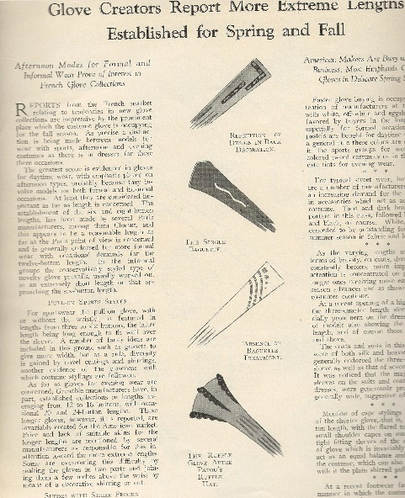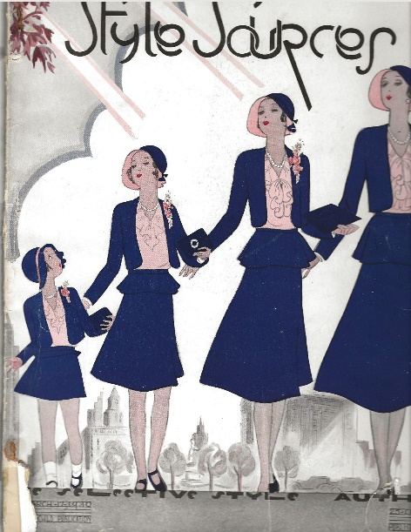

Additional research and review found a second source of documentation, *Women’s Home Companion* October 1931, showing late afternoon gloves without gores.

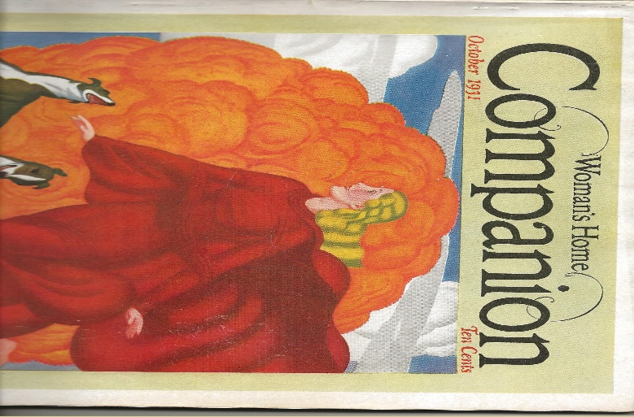

Following the Era Fashion Committee’s policy for documentation review and acceptance as objective evidence, the Era Fashion Committee, April 2020, approved changes to the Fashion Guidelines, 2015 edition to include a sentence referencing the possibility that gloves without gores may be worn with a late 1930-1931 late afternoon and evening ensemble.  The approved additions to the Fashion Guidelines 2015 edition will appear in a Fashion Addendum to be published by early 2021.

The Era Fashion Committee strongly recommends all fashion entrants in MAFCA Fashion Judging present documentation to support using gloves without gores as Coordinated Apparel in the Judging Room.

# # # # # # #