Fashion judging procedures
Manual
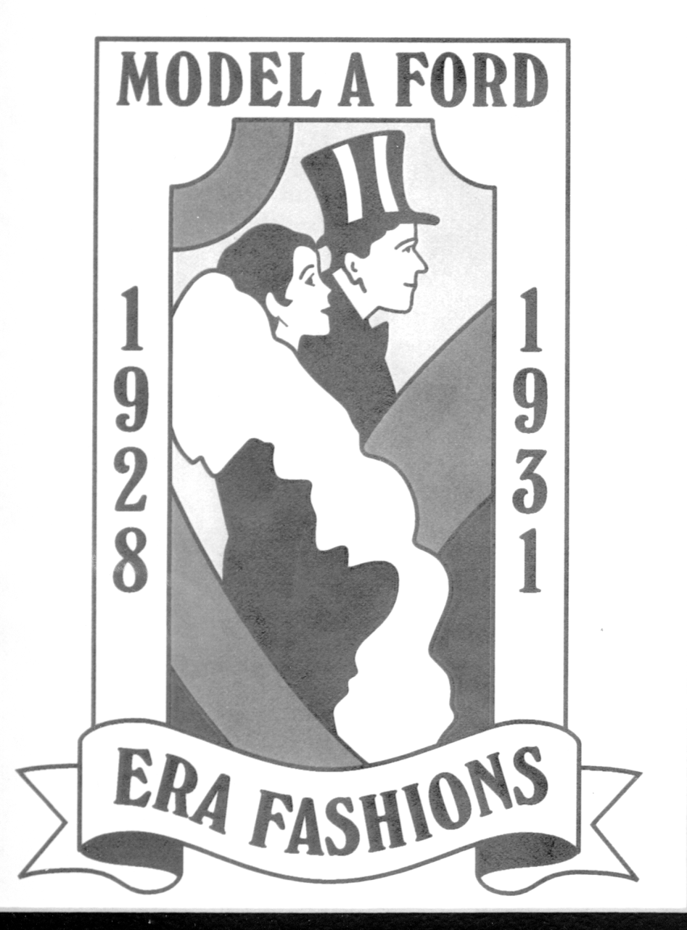

Model A Ford Club of America

FASHION JUDGING PROCEDURES MANUAL
Table of Contents

INTRODUCTION 4
REQUEST FOR MAFCA FASHION JUDGING SANCTION 5
HOST FASHION COORDINATOR 6
General Overview 6
Instructions for Registration Number in Fashion Judging 7
Fashion Show Information 8
Fashion Show Presentation 9
Planning an Era Fashion Boutique 9
Era Fashion Seminars 11
Display Only – Era Fashions 1928-1931 12
Host Fashion Coordinator Checklist 13
Sample Era Fashion Boutique Vendor Letter 16
Sample Seminar Leader Letter 17
Sample Initial Entrant Letter 18
Sample Final Fashion Entrant Letter 19
CHIEF JUDGE 21
Suggestions for the Chief Judge 21
Duties of the Chief Judge 22
Judging Definitions 23
Judges’ Meeting 23
Chief Judge Checklist 26
Pre Meet Activities 26
Meet Activities 26
Post Meet Activities 27
INSTRUCTIONS TO FASHION JUDGES 28
Scoring Guidelines for Era Fashion Judges 28
Original Era Fashions 29
Reproduction Fashions 29
Model A Era Image 29
Overall Appearance 29
Major Garment (Area A) 30
Headgear/Hairdo (Area B) 31
Hats 31
Hairdo 31
Hairdo with Adornments 31
Coordinated Apparel (Area C) 32
Outer Garments 32
Undergarments 32
Accessories (Area D) 33
Footgear (Area E) 33
Shoes 33
Hosiery 34
Scoring 34
Guidelines for Judging Reproduction 35
Seam Construction 35
Seam Finishing 36
Plackets and Closings 36
Hems 37
Details and Buttonholes 37

INTRODUCTION
The purpose of the MAFCA Fashion Judging Procedures Manual is to assist the Host Fashion Coordinator, the Chief Judge, Judges, and Entrants in preparing for MAFCA sanctioned fashion judging at a meet. It is both a planning aid and a guidance manual. The FJPM can be downloaded at no cost from the MAFCA website under Era Fashions, Era Fashion Judging.
If you have any questions please send them to:
Era Fashion Committee Chairperson
MAFCA
250 S. Cypress Street
La Habra, CA 90631-5515

fashions@mafca.com
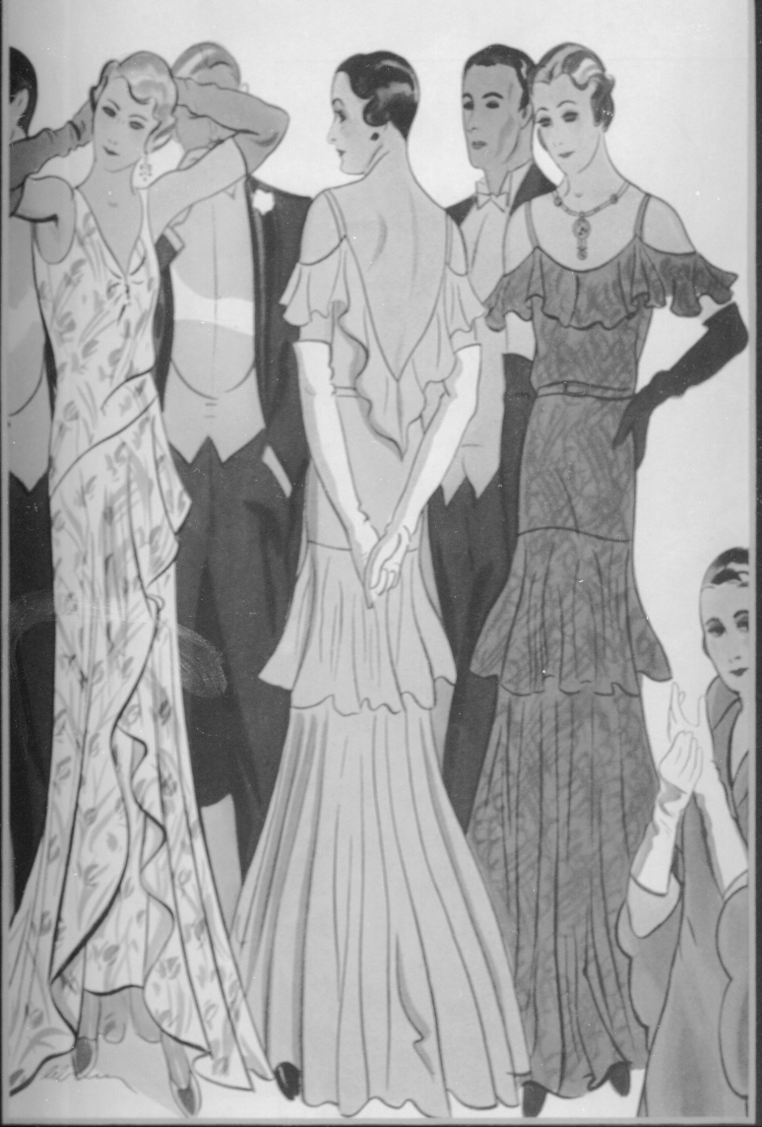

REQUEST FOR MAFCA FASHION JUDGING SANCTION

In order to receive credential credit for fashion judging, MAFCA must sanction the event. To do this, send your request, using this form, to the Era Fashion Chairperson at MAFCA Headquarters. This should be done as soon as you know you will have fashion judging, but no later than 6 months prior to the meet. You will be notified when the approval has been received.
- Is this meet National Divisional Regional Other ___________________
- Meet dates
- Meet location
- Anticipated number of era fashion entrants
- Name of the person you would like to serve as Chief Judge (must be a Senior or Master Judge). For a National Convention the Chief Fashion Judge must be a Master Judge. MAFCA has a list of all judges. You may obtain a copy from the Era Fashion Committee Chairperson.
Chief Judge____________________________________________E-mail______________________
- After receipt of this form, the Era Fashion Chairperson will forward the request to the MAFCA Board for approval.
- Once the approval has been received by the MAFCA Board of Directors, the MAFCA liaison to the Era Fashion Committee will notify the EFC Chairperson who in turn will notify the Host Fashion Coordinator of the event.
- Fashion judging must be conducted in accordance with The Fashion Guidelines.

Download all three sections of the Fashion Judging Procedures Manual (FJPM) from the MAFCA website. You can find it under Era Fashion Judging. The FJPM will give you the information you need for your meet. If you are unable to download the FJPM please notify the EFC Chairperson to arrange for an alternative delivery.

Host Group Chairperson __________________________________ Email _______________________

Signature ____________________________________________________ Date __________________

Host Fashion Coordinator __________________________________Email _______________________

Mailing Address ______________________________________________________________________

Telephone Number____________________________________

Chapter:_____________________________________________________________________________

This is approved by_________________________________________________ EFC CHAIRPERSON

Signature ___________________________________________ Date ___________________________

Approved by MAFCA Board of Directors __________________________________________________

HOST FASHION COORDINATOR

General Overview

In addition to the Fashion Judging Procedures Manual, Section 1 of the MAFCA Fashion Guidelines contains necessary information for the Host Fashion Coordinator. The following information compliments that found in the Fashion Guidelines:

- To insure that no critical activities are missed, use the Host Fashion Coordinator checklist provided in this section.

- Sanctioning: Send the completed Request for MAFCA Fashion Judging Sanction form, no later than six months prior to the meet, to the MAFCA Era Fashion Chairperson, c/o MAFCA for sanctioning of fashion judging.

- If a Co-Host Fashion Coordinator is needed, attempt to appoint someone who is located near you.

- Requesting a Chief Judge: If you have a preference, please state this on your request form. Upon notification of the name and address of the Chief Judge approved for your meet, contact him/her to start making plans for fashion judging at your meet. You and the Chief Judge should have your own copies of the Fashion Judging Procedures Manual.

- Meet Registration Form: Provide a space on the meet registration form for individuals to indicate their desire to judge or to be judged. If the meet will include a “Display Only – Era Fashions 1928-1931” event, add this category, with an event description, to the registration form. (See the section entitled “Display Only – Era Fashions 1928-1931 for further information.) Include a space to indicate if the attendee will have fashions for sale at the Fashion Boutique. Arrange to receive regular updates from your meet registrar regarding the above items.

- Together with the Chief Judge determine the cut-off date for fashion entrants, the time and place of the judges meeting and a short entrants meeting prior to judging. Coordinate plans for the fashion show with the Chief Judge.

- Send the names of those who wish to judge era fashions to the Chief Judge. The Chief Judge will contact potential judges for selection.

- Provide postage and phone reimbursement for the Chief Judge who will handle all correspondence with the judges. Ask the Chief Judge to keep all receipts and send them to you, or the meet treasurer, immediately after the meet.

- Section 3 of the Fashion Judging Procedures Manual contains the Fashion Entrant Information. This information should be sent to each entrant when you acknowledge his/her request (received on the registration form) to enter fashion judging. Include information advising the entrant that these forms are available on-line through the MAFCA website in a fillable format. Whether sending the information by mail or electronically be sure to provide your name, address, and the cut-off date for the fashion entry to be received by the Host Fashion Coordinator.

- Review the numbering instructions for family and group entrants contained in this section. Advise your tally people accordingly.

- Section 2 of the Fashion Judging Procedures Manual contains all the necessary forms for fashion judging, including the Fashion Judging Worksheet, used by those working with the tabulation of scores, and the Master Tabulator Sheet to record the summary information. Instructions for the use of the Master Tabulator Sheet are explained on the form.

- Arrange for refreshments and a breakfast or lunch, as appropriate, for the judges meeting and fashion judging.

- Label each judging station with the area being judged, e.g. Major Garment. Provide table name plates for each judge to be placed in front of their seat.

- Fashion Entrant photography is covered in the Host Fashion Coordinator Checklist.

- If using a computer and printer to tabulate and print worksheet results, be sure to have extra ink cartridges available.

- Provide sharp pencils for each judge.

- Make a copy of the entrant’s form for each judge. Make copies of the Individual Area Worksheets for each judge. They will need one for each entrant in the area they are judging. Original and Reproduction categories use the same worksheet. The worksheets are different for those entrants who are being judged in Model A Era Image. Model A Era Image Worksheets are to be printed on a different color paper. Individual Area Worksheets for Apprentice Judges are also to be printed on a different color paper.

- On behalf of the meet sponsors, give a small “token of appreciation” gift to all era fashion judges, runners, tabulators and other personnel as deemed appropriate.

- Notify the entrant in advance of the date, time, and location of entrant’s meeting; the date, time, and location of their judging; and the date, time, and location of the fashion show. A map is always helpful. If this information is not finalized in time, it may be included in the registration packet, or posted at the registration desk for the meet.

- Era Fashion Awards are covered in detail in the Host Fashion Coordinator Checklist.

- An era fashion seminar is an optional event for the meet. When planning for an era fashion seminar presentation the Host Fashion Coordinator should:

  - Verify that the seminar leader is a current member of MAFCA.
  - Ensure that seminar topics are related to Model A era fashion.
  - Request approval of the proposed seminar leader and topic from EFC Chairperson.
  - Notify seminar leaders of the date, time and approximate number of registrants for their seminar.
  - Ask your presenters what they need for their seminar; perhaps display tables, easels, or someone to give handouts to the attendees.
  - Seminar leaders may print their own handouts and be reimbursed by the Host Club. Alternatively, they may send a master file to the Host Fashion Coordinator for reproduction. The master file must be provided to the Host Fashion Coordinator at least three weeks prior to the meet.
  - Refer any requests from seminar attendees wishing to distribute a handout or literature at a seminar, to the seminar leader. The seminar leader will determine if the handout or literature may be distributed

- Sample letters for Era Fashion Boutique Vendors, Seminar Leaders, and Fashion Entrants are available to assist in planning your event following the HFC Checklist section.

- If you have any questions or concerns, contact the Era Fashion Committee Chairperson, c/o MAFCA, 250 S. Cypress St. La Habra, CA 90631-5515, or by e-mail to Fashions@MAFCA.com.

Instructions for Registration Number in Fashion Judging
Get a copy of the registration list from the meet registration committee. This is the number you will use on each entry form. For families use the following method to assign entry numbers.
Each family has a unique registration number such as 12. In order to tell a wife from her husband and the children from their parents, it is necessary to append a letter to the registration number. We have designated “A” for the husband, “B” for the wife and use “C”, “D”, etc. for the children.
Husband “…A” Child 1 “…C”
Wife “…B” Child 2 “…D” and so on
Members of a group may have multiple registration numbers, in which case a “G” will be added to their registration number, identifying them as part of a group. If there are no family members within the group, no additional identification is necessary. If family members are part of the group, the registration number would be followed by the “G” and the family designation.
Mark the appropriate letters on the score sheet so that the tally committee can credit scoring to the proper person.
Scores will be tallied as score sheets are turned in and a place standing can be determined within a few moments of the last person to be judged while the judges are still assembled. Advise the tally committee when the last score sheet has been forwarded for tallying.

Fashion Show Information

- The Host Fashion Coordinator is responsible for presenting and conducting the fashion show. The jobs should be divided among the committee members, with checklists prepared for designated jobs. All members should have a copy and each must be made aware of the responsibilities of the entire committee.

- The time and effort spent in preparation results in a smoothly run fashion show. Some areas that need to be considered are: publicity, type of fashion show, stage area, movement of participants, audience location, public address system, music, decorations, and type and number of awards. There are many other touches that can be added to make a successful show.

- Select a date, time and location for the fashion show as soon as possible so this can be publicized with the meet events.

- In selecting a room for the show, consider the following points:

  - Ensure that the room is large enough to accommodate proper seating.
  - If available, separate dressing areas for participants are ideal. Security should be provided if dressing rooms are made available.
  - Easy and safe entry and exit from stage (runway) area.
  - A location for the commentator which will not obstruct the audience’s view.
  - Decorations, perhaps in era fashion motif.

- The Host Fashion Coordinator and the Fashion Commentator will each need a copy of each participant’s Fashion Judging Entry Form B and the Master Tabulator Sheet for use in both judging and the fashion show commentary.

- Select a commentator for the fashion show to read the descriptions aloud; no participant should read his/her own. Often times the Chief Judge is willing to do this.

  - Instruct the commentator as to what is expected of the entrants. The commentary may be amusing and entertaining but not at the expense or embarrassment of the participant.

  - The commentator should be given the opportunity to read and familiarize him/herself with the text of descriptions in advance. A copy of the entry form may be used for this purpose, saving the original for the Chief Judge.

- Keep the participants relaxed and in the spirit of having fun.

Fashion Show Presentation

- As Host Fashion Coordinator, be sure to check your time schedule plans for the fashion show with the Chief Judge in advance. The Chief Judge needs to insure that the fashion judging tabulation is completed accurately and the placement for awards has been accomplished prior to the Fashion Show. If the show is scheduled for the same day as the judging, allow adequate time between the completion of the judging and the actual show for tabulation and award placement. The order of appearance is the choice of the Host Fashion Coordinator who should consult with the Chief Judge before making this decision.

- During the entrant’s meeting, provide each entrant with written or verbal instructions on the fashion show process, time, location and expectations.

- If time allows, a rehearsal for the show is important to familiarize entrants with the show expectations. You may want to enlist the assistance of someone with a fashion modeling background to assist entrants with “runway” procedures.

- At least one usher should be near the entrance to assist the entrant and give instructions.

- If the exit is different from the entrance, an usher should be available to assist the entrant off the stage.

- The commentator should begin with announcing the name of the entrant, the specific category, class, division and then a description of the entrant’s apparel. The commentator may stylize their description of the entrant with good taste, common sense and consideration for the attention span of the audience. Announce the award given, not the total points earned.

- The entrant steps on the stage as his/her name is announced and walks slowly to the center stage (or where the runway begins). They should stand for a moment, count to five, slowly turn a half revolution for a back view, count to three and complete the turn. The entrant should then move to the runway, if any, and repeat the stage actions at least one more time. The entrant should remain on the stage or runway until the commentator has read the complete description of the ensemble.

- The same pattern should continue for all entrants until the show is completed.

- Photography by the audience should be allowed but should not interfere with the actual fashion show. Consider this and make necessary arrangements.

Planning an Era Fashion Boutique

- A fashion boutique is an ideal place for all those persons who are interested in Model A fashions and related items. At a meet it will be a place for registrants to bring items for sale or to find that ever-elusive item to complete an outfit. It is a source of learning as well as sharing of knowledge about Model A fashions.

- Interest in Model A fashions and related items has become a very important part of our wonderful hobby. Whether participants are interested in fashion judging or the wearing of era fashions, the era fashion boutique will be a favorite spot at any meet.

- There are two types of fashion boutiques. In one, the sponsor is responsible for all aspects of the boutique, from the display of the merchandise all the way through the sale and final disbursement of income from sales. Alternatively, individual sellers can be responsible for their own set up and sales. Either way is acceptable, but vendors must be notified in advance of the method to be used.

- The meet registration form should have a place for the registrant to indicate a desire to sell fashion boutique items. With this information you can send pertinent information to the sellers, including hours for accepting merchandise, tagging criteria, specific time for picking up unsold merchandise, etc.

- Special arrangements should be made for setup and removal of merchandise with a seller who has a large inventory.

- Food and drink should not be allowed in the room. Signs to that effect should be posted, both inside and outside the room. A garbage can should be placed at the entrance to the room.

- When planning your space, you need to know what type of items you are going to have and assign space accordingly. Select a room large enough to accommodate an easy flow of buyers. Use name placards to identify boutique seller’s tables in the sales area. This will help both you and the sellers on set-up day. Arrange merchandise before the doors are opened. It may take several hours to accomplish this task, so be sure to allow enough time for setting up the era fashion boutique.

- State a deadline for changes to a seller’s required number of tables. However, sellers in the boutique may not adequately communicate their space requirements. Attempt to be flexible and accommodate any additional needs they may have.

- If displays are included as part of the boutique, separate the display area from the sale area. A separate display area will allow people to look at their leisure and study the articles being shown.

- The sales area may consist of three types of sellers; registrants, the boutique host, and/or professional vendors.

  - Registrants of the meet may sell their items directly and are responsible for all items and sales. They are expected to set up their display and remove unsold items from the boutique. They pay only a flat fee.
  - The registrant may provide merchandise for sale, pay a flat fee and perhaps a percentage of their sales (10% is recommended).
- The host is responsible for set up, sales, and disbursement of sales income to the registrant.
- There should be a central cashier or cashiers accepting payment, recording sales, writing receipts and packaging the purchase.
  - Professional vendors, which you have solicited expressly for this sale, could be local area vintage clothing dealers. Professional vendors add an extra dimension to the boutique. A specific amount of space would be rented to them for a flat fee. To help defray boutique expenses, e.g. room and equipment, the host club may charge the seller a small percentage of sales (perhaps 10%) of merchandise sold. The seller is expected to handle their own set up and sales.

- Equipment is very important. Having the proper equipment can make the sales area much more efficient. This equipment may be purchased, rented or possibly borrowed from local merchants. Suggested equipment might include: clothing racks, shelves for shoes, locking showcases, tables, adding machine, secure money box, screens for try-on areas and several mirrors.

- The next area of great importance is making sure you have enough personnel to operate the room efficiently.

  - There should be one person in the fitting area at all times. This person should have a measuring tape to measure the items that are questionable for fit. This person would also help people to get in or out of garments without damaging them.

  - There should be another person to answer questions. If you don’t have someone knowledgeable in era fashions contact the Era Fashion Committee Chairperson for suggestions. It is also a good idea to have a copy of the MAFCA Fashion Guidelines available for reference.

  - There should be someone to watch the entrance, make change, etc.

  - There should be two people at the check-out table to record the sale, make out the receipt and package the purchase. Be sure to detach seller’s tag and return it to the seller for their records. Alternatively, seller’s can staff their own table and collect their own money.

- With the understanding that the host club cannot be held responsible for lost, stolen or damaged merchandise, a disclaimer to that effect should be signed by each seller. Persons bringing articles for sale should be responsible for clearly marking their own merchandise as to size, (it’s a good idea to use measurements instead of modern sizes) era, (1928-29 or 1930-31) and price. Tags should be clearly marked with seller’s last name and/or registration number. Tags are best when 1 ¾” by 1” are used. If a vendor wants their special hangers returned, a bag with their name on it may be provided. A small file case would be helpful to hold a manila envelope for each seller. Mark the outside of the envelope with the seller’s name, registration number and how they can be reached in case of questions. Place completed sales tags, stapled to receipts, in individual envelopes of sellers.

- Buyers need to pay the meet sponsors by acceptable payment methods. If accepting checks they need to be made out to the meet sponsor, or seller, as determined by the sponsor. All proceeds should be turned over to the meet treasurer or an individual appointed by the Host Fashion Coordinator who arranges for appropriate deductions, such as any seller’s fees and disburses the proceeds to individual sellers.

- Make it very clear to the buyer that all sales are final. A sign at the sales table noting this policy is a must. An “All Sales Final” stamp for the receipts would also be advisable. Adhering to this policy will make the sale process less complicated and make the sales fair to all buyers.

- Remember that we are trying to encourage more Model A’er’s to add era fashions to their hobby, so keep the boutique area a fun area and have the MAFCA Fashion Guidelines handy for reference and be prepared to answer questions. You may also post a sign indicating some items may not be of the Model A era, so buy with caution and refer to the MAFCA Fashion Guidelines for help.

- You may contact MAFCA for suggestions from previous meet events.

Era Fashion Seminars
Seminars, while optional, can be an integral part of the fashion aspect of a meet. The following topics are suggestions only and are not intended to limit the variety of seminars that can be presented. If you need help in identifying a seminar leader, contact the Era Fashion Committee Chairperson either by letter to MAFCA, 250 South Cypress Street, La Habra, CA 90631-5515 or by e-mailing Fashions@mafca.com. (Additional seminar information can be found in this section of the Fashion Judging Procedures Manual.) Seminar Leaders are required to submit a copy of a handout, if used, and an outline of their presentation to the Era Fashion Chairperson six (6) weeks prior to their seminar (MAFCA Fashion Guidelines, Section 1).

Accessories

A Touch and Feel Seminar

Care/Restoration of Era Fashions
Children’s Era Clothes

Coordinated Apparel

Era Powder, Paint and Perfume

Model A Era Image

Fans

Fashion Judging
Fun with Era Fashions

Furs

Getting Started in Era Fashions

Hats

Hairstyles

Jewelry

Knickers

Major Garment

Men’s Fashions

Parasols and Umbrellas

Patterns/Sewing

Purses

Reproduction Fashions

Researching Era Fashions

Shoes and Stockings

Shopping for Era Fashions

Wigs

Display Only – Era Fashions 1928-1931

The fashion activity called “Display only” is an optional event that can be used to add interest to your meet. It consists of the viewing of era fashions from 1928-1931 through the exhibition of these fragile items. This event appeals to all attendees who enjoy fashions. It allows members the opportunity to share some of their collection with the attendees. This event can be used to augment a fashion tea or lunch, with the displays placed around the room. Alternatively it can occur at another time as a stand-alone opportunity for viewing during the meet. Displays of era ensembles should be placed on tables in a central viewing area, similar to what might be seen in a museum display of period clothing. Some displays might consist of an entire ensemble of a major garment, headgear, coordinated apparel, accessories, and footgear, while others may be a combination of fashion related items. The Host Fashion Coordinator determines if this event is right for the meet.

Make sure the meet registration information describes the event and registration form allows for interested parties to sign up for the event. Once you know who will be participating, obtain a brief description of the display from the participant. Communication with the participant should include the following:

- When and where to set up their display
- The hours the display will need to be available for viewing
- When to take down the display

Awards for this event are optional. A people’s choice award, or a panel of judges, appointed by the Host Fashion Coordinator, could determine awards. If given, these awards can be incorporated into other award presentations. You will be responsible for obtaining the supplies needed to stage the display, i.e. tables, table cloths. You will need to arrange with the host location for space to stage the event. It is strongly recommended that some form of security be provided to protect these displays.

Host Fashion Coordinator Checklist

1. Get a copy of the Fashion Judging Procedures Manual, Forms for Fashion Judging and the Fashion Entrants Information (Available on website)

2. Request MAFCA Sanctioning – Send form to Era Fashion Committee Chairperson

3. Request Chief Judge – Your choice or one recommended (MAFCA approved)

4. Plan what era fashion events you will have.
A. Era Fashion Judging
B. Era Fashion Show, Luncheon, Tea, or Banquet
C. Era Fashion Boutique
D. Era Fashion Seminars
E. Era Fashion Display (Display Only)
F. All events need to be on the Registration Form and advertised
G. Make sure you have adequate signage to direct participants to all the fashion events.

5. Contact Chief Judge when you have MAFCA sanctioning as you will be working together on many facets.
A. Discuss details of Fashion Judging
- Cut off date for accepting Fashion Entrants
- Send list of potential Judges as they register
- Send list of entrants as they register to the Chief Judge
- Make a copy of the MAFCA Judging Entry Forms A and B and send the originals of MAFCA Judging Entry Forms A and B to the Chief Judge, along with any supporting documentation
- Location of judging room and set up ________________________
- Time of judging ____________________________
- Schedule how many entrants your allotted time allows (15 min. x __ = ____)
- Allow enough time between judging tabulation and the fashion show
- Discuss what Judging Forms will be needed
- Arrange for refreshments and/or lunch if appropriate
- Judges Meeting prior to judging day or a breakfast the day of judging

  - Location and time ___________________________________________

- Entrants Meeting – Day before judging to advise them of their judging time and last minute information.

  - Location and time ____________________________________________

- Trophies and Awards
- Name of Tabulator _______________________________________________
- Photographer
- Offer Chief Judge reimbursement for postage and copies

B. Discuss details of Fashion Show
- Location and time of show _____________________________________
- Who will be commentator ______________________________________
- Program
- Stage, ushers
- Trophies
- Photographer _______________________________________________

6. Fashion Entrant Information
- Send packet to each entrant, either by mail or e-mail, as you receive their registration (FJPM, Section 3)
- Inform entrant that on-line fillable forms are available on the MAFCA website
- Specify a due date for return of the signed entry form
- Notify entrants about entrants meeting, time, and location

- If possible, find a local hairdresser capable of styling hair in era fashion for entrants who wish professional hair styling. Beauty schools can be a great resource. Communicate this information to the fashion entrants.
- Make 6 copies of their returned MAFCA Fashion Judging Entry forms, A and B
- Copy any documentation they send (6 copies or depends on judging area)
- Send one copy of each entrants returned entry forms A and B plus any documentation to the Chief Judge
- Retain the 5 remaining copies of the entrants returned information for judging day. The Chief Judge may need these prior to judging day to arrange them according to the entrants scheduled judging time.

7. Fashion Judging Room
- Set up the judging room as early as possible prior to actual judging.
- Arrange for tables, chairs, water, and glasses
- Make signage for each Judging Area (5) and judges names
- Copies of Individual Area Worksheets (A, B, C, D, and E)
- There are two different forms - Model A Era Image and Original/Reproduction
- Model A Era Image Worksheets are to be printed on a different color paper
- Individual Area Worksheets for Apprentice Judges are to be printed on a different color paper
- Sharp pencils for each area
- Fashion Entrants Entry Forms (5 copies of each entrant form you’ve received)
- On judging day a sewing kit, including safety pins, will help with any last minute repairs
- Ushers and Runners prepared for their jobs
- Check heat/air and lighting
- Give small “token of appreciation” gifts to the Judges, Chief Judge, Assistant Chief Judge, Runners, Tabulators and other helpers as appropriate.

8. Fashion Entrant Photographs
- Make sure the photographer understands the time required to take photos of the fashion entrants. Avoid any schedule conflicts with other convention events.
- If you don’t know all of your entrants, use a placard with the entrant name and registration number for the first photograph. Then take the second photograph without the placard that will be used in The Restorer magazine.
- If you are using a picture frame trophy as an award, make sure your photographer knows your photo size requirement and the appropriate entrant position within the picture.

9. Arrange for Trophies for the Era Fashion Entrants
- Best of Each Category - Special trophies may be made for the Best of Each Category fashion awards. Suggestions are for a single trophy with both awards listed, a different trophy for each person, flowers or other gift or appropriate form of recognition to acknowledge the achievement.
- Have enough trophies made for each entrant. MAFCA medallions are also available from MAFCA headquarters.
- If possible, work with a local trophy company close to the meet location. This can give you a quick turn-around time for name/placement plaques, allowing you to give the entrant a complete award. Have a “tool kit” available to attach the plaques to the awards. If this is not possible, the personalized plaque can be sent after the meet, generally within thirty days.
- Trophies should be prepared without an award placement designation as this should be included on the plaque
- Note: Award of Excellence Pins are awarded only at National Conventions. Please request pins from MAFCA Headquarters.

10. Fashion Show
A. Planning
- What (luncheon, tea, banquet, etc.), When and Where
- Commentator
- Program
- Trophies / Awards
B. Set Up
- Stage and Seating
- Ushers to assist Fashion Entrants on/off stage
- Entrants line up where
- Equipment needed (podium, microphone, etc.)
C. Photographer (Separate staging area suggested for better flow of entrants)
D. Awarding Trophies – Who and When

11. Era Fashion Boutique
A. Select Time and Location
B. Decide who will be responsible for the sales and the money, the host group or the individual sellers.
C. Notify participants of set up/pickup time
D. No food or drink allowed
E. Equipment
- Coat racks, hangers, tags/labels, tables, chairs, showcases, calculator
- Screens/dressing room, mirrors, dressing assistants, measuring tape

12. Era Fashion Seminar
- Seminar topics should relate to Model A era fashions
- Request approval from EFC Chairperson of the proposed leader and topic
- Seminar leader should be a MAFCA member
- Seminar leaders outline and handouts are to be sent to the EFC Chairperson six weeks prior to the seminar for approval

13. Era Fashion Display Only
- Obtain a brief description of the display from the participant
- When and where to set up/take down
- Hours of display for viewing, possible security needed
- Awards optional for this event

Sample Era Fashion Boutique Vendor Letter

Dear _________________,

We a pleased that you have chosen to be a fashion vendor at the Meet Name in Meet Location . Here are the guidelines for the Era Fashion Boutique.

DATES: Set-up - Day, Date, Time
Sale - Day, Date, Time

LOCATION:

- You will have one table, one hanging rack and two chairs. The approximate table size is measurement . If you think you need more space, let me know by Date . There are no booths. (Modify this paragraph to reflect your set-up.)

2. A placard with your name will identify your designated space.

3. No food or drink will be allowed in the boutique room.

4. Bring your own hangers, sales bags and any other items, such as a table mirror, that you need to display your items.

5. You are responsible for collecting the money for your sales.

6. Unsold items must be removed by Time on Day and Date .

7. Anything not removed by Time and Day will be boxed and given to a charitable organization.

If you have any questions that have not been addressed here, please let me know. I can be reached via email email address or phone at .

I look forward to seeing you in Meet Location .

Host Fashion Coordinator

Sample Seminar Leader Letter

Dear _______________,

Thank you for agreeing to be an Era Fashion seminar leader at the Meet Name . Your seminar, entitled Seminar Name , is scheduled for Day, Date and Time .

Please let me know by Date what equipment you will either bring with you or need for your seminar. A microphone and a display table will be provided for your seminar.

In accordance with the MAFCA Model A Era Fashion Guidelines, Section 1, page 27, you need to provide a written outline of your presentation at least six weeks prior to the start of the meet to the Era Fashion Committee Chairperson. The EFC Chairperson will respond to you with any comments or suggestions within ten days from receipt of your outline.

If you have seminar handouts, you may print them yourself and submit a receipt to me for reimbursement. Alternatively you may send me the file, preferably a PDF, by Day and Date and I will have them printed and ready for your seminar.

As the date of the meet draws closer, I will let you know how many people have registered for your seminar. If you have any questions, please let me know.

I look forward to seeing you in Meet Location .

Host Fashion Coordinator

Name and Contact Information/ Email Address

Sample Initial Entrant Letter

Dear __________________,

We are thrilled that you have chosen to be an entrant in Era Fashion Judging at this summer’s MAFCA
National Convention in location . Our Chief Judge is Name from the club affiliation . Our Assistant Chief Judge is name and club affiliation if ACJ is appointed .

Harriet McNeill and Lynette Marcione have written articles that provide a wealth of information that can help you prepare for judging. These articles can be found online at MAFCA.com>Era Fashions>Articles. Harriet’s article is entitled “Jazz It Up” and Lynette’s article is “Entering Fashion Competition at MAFCA Sanctioned Events.”
Should you wish to have your hair professionally styled in era fashion, we have identified the following hairdresser(s) capable of doing so. Include name, address, and phone number of hairdresser(s).
For your convenience, we have included the Fashion Entrant Information Section of the Fashion Judging Procedures Manual as well as Fashion Judging Entry Forms A & B. These are your next steps.
1. Complete MAFCA Fashion Judging Entry Forms A & B in one of the following ways:
a. Online at MAFCA.com>Era Fashions>Judging Forms>Fashion Judging Entry Form. You will need to save and print the form after filling it as the form cannot be submitted from the website.
b. Manually, please print when completing the form.
2. By date return the completed forms to HFC name by one of the following means:
a. Email: _________________________________

b. Mail: _____________________________
_____________________________
_____________________________

3. Questions?
If you have any questions, feel free to send an email to name, email address and phone number of HFC .

We look forward to seeing you in Meet Location .

__________________________________
Host or Co-Host Fashion Coordinators
Enclosures:
Fashion Entrant Information Section
MAFCA Fashion Judging Entry Forms A & B
Return Addressed Envelope

Sample Final Fashion Entrant Letter

Entrant Information for Fashion Judging

Dear ______________,

Here is some advance information regarding your participation in fashion judging and the fashion show.

Day and Date .

Fashion Entrants Meeting - Time and Location .

Day and Date .

Fashion Judging - Location & Judging Time .

Please let us know as soon as possible if you have a time conflict and we will attempt to reschedule you.

If you have documentation, other than the Fashion Guidelines or Fashion Facts Book, and did not send it with your entry, please bring a copy with you to the judging room.

If you provided a copy of your documentation with your entry, there is no need to bring a duplicate set.

Please arrive at the Location 10 minutes prior to your appointment. From there you will be escorted to the photography area and then to the Judging Room.

You may choose to dress in your hotel room or in the Room, if applicable . Private changing areas will be provided in this room. Name will be there to assist you should you need help. You will be able to check your outfit in the mirror one last time before entering the judging room

When you enter the judging room proceed to the center of the room so the judges can get an overall look at your ensemble. The Chief Judge will read the description of your outfit as you turn around slowly. The Chief Judge will instruct you to proceed to the individual judging areas.

There will be one to three judges for each area. Judges may ask you questions about your outfit. After judging is completed and you exit the room please remain in the area in case the judges have additional questions. The Chief Judge will let you know when you can leave.

Day and Date .

Event Name and Award Presentation - Time and Location .

Description of event, if food will be served, etc. . As an entrant you will have designated seating. Please let us know if you plan to bring a guest with you. The Room name, if this sentence applies is available for changing if you prefer to change into your judged ensemble after the meal.

If applicable, further description of fashion show, e.g., There will be two segments to the fashion show. The first fashion showing will be the judging team. Then, the fashion awards segment begins and you will show your judged ensemble.

You will be directed to the assembly point, advised of your position in the lineup and when to enter the stage. Go to center stage, pause and do a complete turn. Proceed down the catwalk pausing in the center to do a full turn around again and exit as directed. The commentator will describe your ensemble as you are walking the catwalk and announce your award. You will be assisted in descending the stairs and then given your award. You may then return to your seat.

At the conclusion of the event please reassemble at the stage for a group photograph.

If you have any questions, feel free to contact Name and contact information . We hope you will enjoy your fashion judging experience.

________________________
Host Fashion Coordinator

CHIEF JUDGE

The Chief Judge for a national meet is automatically a non-voting member of the Era Fashion Committee until the conclusion of the national meet. This term shall expire and no reappointment can be made. The Chief Judge may attend all Era Fashion Committee meetings at their own expense.

National meets require an Assistant Chief Judge. For a national meet, the Assistant Chief Judge must be a Master Judge. For all other meets, appointment of an Assistant Chief Judge is optional. If an Assistant Chief Judge is appointed, it is the Chief Judge’s responsibility to guide, direct, and educate the Assistant Chief Judge in all aspects of their responsibilities if appropriate.

Suggestions for the Chief Judge

Carefully study the MAFCA Fashion Guidelines, Section 1, regarding judging and the Host Fashion Coordinator’s duties. The Chief Judge checklist begins later in this section.

Request a current copy of the Fashion Judges Roster from the EFC Chairperson in order to assist you with the selection of judges. Eligible judges are those who have judged within the past 5 years. Judges whose certification has lapsed may certify their credentials by taking a re-certification test available through MAFCA headquarters or downloading the test from the MAFCA website, under Era Fashions, Era Fashion Judging.

Keep in close contact with the Host Fashion Coordinator during the time of planning. Advise all fashion judges to download the “Instructions to Fashion Judges” section of the Fashion Judging Procedures Manual (FJPM), from the MAFCA website. Major Garment judges should also download the “Guidelines for Judging Reproduction” found in this section of the FJPM. If any judge is unable to download the required documents, send them a copy. If you have questions or concerns, please contact the EFC Chairperson through the MAFCA Office, fashions@MAFCA.com.

Working with the Host Fashion Coordinator, schedule a meeting with the era fashion judges either the day preceding judging or a breakfast meeting the day of the judging. This should be a well-planned business meeting to give information and to deal with any questions or problems that may arise. The second part of this meeting should be a time when each of the five judging teams can meet together with copies of the entry forms to preview their particular area. This session will give them an opportunity to ask questions, make procedural decisions and do further research before the actual judging. This meeting is usually scheduled for about one hour. Information on the judging schedule and the fashion show details should also be given. Ask the Host Coordinator to have at least six copies of each entry form available – one copy for the Chief Judge and one copy for each of the five judging teams. These forms should be collected at the end of the meeting and redistributed at the time of judging.

You and the Host Fashion Coordinator should decide together if you wish to schedule a short entrants meeting. The purpose of this meeting would be to give the entrants final instructions, show them where the judging will be held, let them know the schedule for judging and give them information about the fashion show. This meeting should also help the entrants feel more comfortable and allow them an opportunity to meet other fashion entrants.

The issue of the amount of time to judge each entrant is critical. If judging gets backed up and entrants are waiting too long frustration sets in. In addition, those waiting will see their outfits wilt before their eyes, wrinkling and losing their creases. Be cognizant of this possibility and have a backup plan if this happens. It is suggested that 10 to 15 minutes be allowed per entrant. If judging starts to lag, be aware of the time element and move the judges along.

As the Chief Judge, you set the mood for the fashion judging. Judges and entrants alike need your enthusiasm, sensitivity and encouragement.

Duties of the Chief Judge

The Chief Judge shall select judges and make assignments, supervise all judges in judging matters, conduct judges meetings and resolve judging questions, which arise during the judging process. A Chief Judge shall not make judging score determinations or enter judging points on the score sheet. The Chief Judge oversees all judges and tabulators.

In the case of fewer than 5 judges, the Chief Judge can assign an experienced judge to judge 2 categories.

In the event a score is questioned, the Chief Judge may return the worksheets to the judges for their reassessment and re-evaluation.

In the case of a tie in points, the tie will be broken by a decision of the judging team, which will consist of the team captains. The Chief Judge or Assistant Chief Judge will call for and facilitate this decision. The decision of the judging team will be final.

The Chief Judge does not score or change scores, but always reserves the right to question the scores. If a question arises, the Chief Judge must know how to reach the judges after the judging team has been dismissed.

The Chief Judge collects all scored worksheets upon final tabulation, including those of Apprentice Judges. The Chief Judge is responsible for safeguarding these documents.

The Chief Judge evaluates the apprentice judging sheets and sends a letter to the Apprentice Judge regarding their judging proficiency, with a copy to the Era Fashion Committee Chairperson.

The Tabulators will provide the Chief Judge with the completed Master Tabulator Sheet summarizing the entrant’s information and overall score. The Chief Judge will enter the earned award on the form and give a copy of the completed form to the Host Fashion Coordinator. It is not appropriate to round the final tabulated score, up or down, to determine any award given.

The Chief Judge, after reviewing all tabulated worksheets, shall transfer all scores and judge’s comments to the Judging Results form. The Chief Judge may amend the comments of a judge to reflect tact, consideration for personal feelings, and diplomacy, if appropriate. The Chief Judge will distribute the scores and judges’ comments to the fashion entrants using the Judging Results Form.

Following the meet, the Chief Judge will send the original scored worksheets, the completed Era Fashion Judges Record, the Score Sheet, the Evaluation Sheet on Apprentice Judges, the Fashion Judging Results and photos to the Era Fashion Committee Chairperson. The original judging worksheets and records will be retained by the Era Fashion Committee Chairperson for 3 years.

Original copies of all judging scoring sheets with any entrant’s documentations and photographs must be sent to the EFC Chairperson for retention for3 years.

The Chief Judge and the Host Fashion Coordinator will jointly make the following decisions:

- The time and location of the fashion entrant’s meeting.
- The order of judging of Original, Reproduction and Model A Era Image fashions. For example, should all original entries be judged first, then reproductions, and finally Model A Era Image, or should they be interspersed?
- The need for a second judging room based on the number of entrants and judges.
- What the order of the fashion show will be. Many options are available: children and juniors first, followed by sportswear, specialty and daytime and concluding with formal wear; or by Original, Reproduction and Model A Era Image; or some other variation.
- How and when official photos of the entrant will be taken. Photos are a useful tool when resolving questions.

Judging Definitions

Team of Judges: Two or more judges selected to judge in one of the five areas of fashion judging. The team judge having the highest certification shall enter points on the judging score sheets. If two judges have the same certification level, the Chief Judge will appoint one as the Team Captain. There may be occasions when a team will consist of only one judge.

Sanctioned Judging: A fashion judging event, approved by the MAFCA Board, in which the MAFCA Fashion Guidelines are used for judging.

Records: The Era Fashion Committee Chairperson shall maintain a master record of all certified MAFCA fashion judges. This record shall include the judge’s name, contact information, last date as an entrant, last date judged, tests passed, judging experience and status. For a Master Judge, a record of seminar(s) and/or articles published in The Restorer shall be recorded.

Judges’ Meeting

A judges’ meeting will be scheduled prior to the start of any judging. This meeting shall be a closed meeting. Attendees shall include:

- Chief Judge
- All judges responsible for scoring entrants
- All apprentice judges
- Host Fashion Coordinator
- Personnel to assist the Chief Judge, including the Assistant Chief Judge, Tabulators, Runners, ushers and judges commentator
- Any other persons responsible for conducting any aspect of the actual fashion judging process
A separate meeting is recommended for the tabulators and runners if they are inexperienced in this function. The Chief Judge or the Assistant Chief Judge conducts this meeting. Furnish the tabulators with all the instructions needed to tabulate the scores as per the MAFCA Fashions Guidelines, Section 1. Include examples of completed forms. If available, an additional judge might be used to supervise the actual tabulation, especially at a large meet.

The following information is to be related to all:

- The number of entrants. This should include a breakdown of category, class and division.
- No one is to make any comments or gestures that could cause any discomfort to the entrant.
- Tabulators will be instructed on how to tabulate worksheets as per Section 1 of the MAFCA Fashion Guidelines; runners will be instructed in their duties to relay information and/or questions between the judges room and the tabulators.
- Ushers will be instructed on how to line up entrants in the waiting area and escort them to and from the judging area. Instructions on how to take entrants to and from the photographer may also be included.
- Instructions to any person present responsible for conducting any other aspect of judging should also be included here, with the exception of the judges.
- The judges’ commentator will receive copies of the entry forms. Instructions on how to present the information shall include: reading the entrant’s name, category, entrant number, divisions and class. Each area will then be read fully, beginning with Area A. If an area has no information, state that the area has been left blank. Depending upon how judging is arranged, there may be no need for a commentator. The Host Fashion Coordinator will be advised in advance as to the necessity for a commentator.
Following the above presentation, those who have received their instructions may leave or remain.

Judges’ instructions will include:

- Introduction of the Chief, Master, Senior Judges, Judges and Apprentice Judges and assignment of seating arrangement.
- Instructions to place the registration number in the upper right hand corner of the Fashion Judging Worksheet.
- Instruct judges to write constructive comments meant to assist entrants in improving their ensembles, whenever points are deducted. Complimentary comments should be written as well.
- Repeat the number of entrants and order of appearance in the judging process.
- Review all information relating to judging within these guidelines and other information helpful for judging.
- Stress consistency throughout the entire judging process.
- If a judge has concerns about the judging process, they should address those concerns with either the Chief Judge or the Era Fashion Committee.
- Any judge who assisted an entrant with their outfit, or advised the entrant (prior to the meet), or is a relative of an entrant must leave the judging room prior the entrance of that entrant.

As a Chief Judge, you deal with the challenge of the judges keeping an entrant’s score as fair and balanced as possible. In your judges meeting you might consider sharing the following information to assist them.

Scoring Overall Appearance

The primary purpose of scoring the area of Overall Appearance is to recognize the entrant who exemplifies the fashion look of the Model A era.

The actual scoring of Overall Appearance starts as the entrant enters the judging room, and ends as they exit. To commence the process of judging Overall Appearance, each judge begins with the mid-range point value of the Overall Appearance area. For the categories of Original and Reproduction, start at the point value of two points. For Model A Era Image, start at the point value at 10 points. As the entrant presents themselves, the judge will move the points up or down based on their opinion and knowledge of how closely the entrant has represented the Model A era.

For example, if an entrant has correctly done her make-up and nails in era fashion, it would be considered as an extra effort and would add to their look of the Model A era. If a man’s facial hair is correctly done in era style, that extra step could be rewarded. These efforts could result in additional points in the Overall Appearance area, providing there are no other distractions that take away from your opinion of their appearance and how well it represents the Model A era.

It is important to note, this area contains an element of subjectivity, there is no specific formula for adding or subtracting points to your mid-range starting point value. What is important to remember is, all judges are starting at the same place. Ask yourself, “Does this entrant look as if they stepped out of the Model A era?” If so, you decide, based on your opinion and knowledge, to what degree they represent the era and how many points to award. If there are distractions to the Model A era look, you decide to what extent these elements are taking away from the authentic Model A era appearance. In all three categories, you determine how much weight you want to add or subtract from the mid-range starting point values.

Scoring Coordinated Apparel
Often times an entrant will present multiple items to be judged in the area of Coordinated Apparel. However, the total points allowed sometimes makes scoring several items more difficult. How many points do you allow for each item? As an aid to your thinking on how to score multiple items, consider dividing the total number of items to be judged into the total points available. For example, a gentleman entrant presents four original outer garments to be judged. They are a shirt, tie, belt, and a top coat. The individual area worksheet allows for a possible eight points for Original and Reproduction. You have four items, so each item has a point value of two points. If one of the items is not correct you will deduct two points. The formula is less perfect as you continue to score for condition, fit, coordinated, and appropriate. Use your judgment to attempt to score these remaining attributes with as much equality as possible. If you can equalize the points with the number of items being judged, do so.
The individual area worksheet for the category of Model A Era Image is slightly different. However, you can apply the same basic idea in balancing the score.

Chief Judge Checklist

Pre Meet Activities

- Study the MAFCA Fashion Guidelines (Section 1, regarding judging)
- Study the Fashion Judging Procedure Manual (MAFCA website)
- Review Host Fashion Coordinator (HFC) duties
- Keep in contact with HFC, and Assistant Chief Judge if assigned, regarding all details
- Planning and scheduling of Judging and the Fashion Show
- Names of Judges and Entrants as they register
- Names of runners and tabulators
- Judging room set up and items needed (Forms, pencils, etc.)
- Study HFC Checklist

- Request current Fashion Judges Roster from MAFCA or current EFC Chairperson
- Select Judges and make assignments
- Appoint Assistant Chief Judge (National) and assign duties. At Regional meets, the appointment of an Assistant Chief Judge is optional.

- Notify Judges of their assigned judging area and advise them to study their area as well as the Fashion Judging Procedures Manual, Instructions to Fashion Judges, FJPM 1, Main Section.

Meet Activities

- Schedule and conduct an Era Fashion Judges meeting
- Obtain contact information for all Judges (Cell phone or room number)
- Schedule and conduct entrants meeting for final instruction (day before judging)
- Inform Entrants of judging location and changing area
- Introduce Entrants
- Their judging time
- Fashion Show location, time and stage instructions
- Answer questions they may have
- Encourage entrant to provide feedback on their experience
- Entrants should notify the Chief Judge if there is a conflict with their assigned judging time
- Inform entrants of picture location and time
- Need for the entrant to provide documentation if necessary
- Inform entrants of the location of the posted judging schedule

- Judging Day
- Oversee Judges and Tabulators
- Give Judges a copy of each Entrant’s entry form
- Introduce Entrant, read entry form if no judges commentator is being used
- Resolve any questions, including your own, that arise during judging
- Be prepared to suggest Entrant change categories if advantageous
- Keep on schedule
- Resolve any tie with team captains
- Collect scored worksheets and Master Tabulator Sheet from Tabulator
- Review scoring and awards
- Enter awards on Master Tabulator Sheet and give a copy to the HFC
- Coordinate awards and fashion show with HFC

- Era Fashion Show
- Work with the Host Fashion Coordinator to determine personnel needed to assist
- Work with the Host Fashion Coordinator to line up Entrants
- If you are not the commentator, provide the entrant information and description to the commentator
- Insure that when the award announcement is made, the points earned are not mentioned

14. Safeguard Entrants Worksheets
- Save a copy of each Entrant’s worksheet
- Transfer scores and Judges comments to Fashion Judging Result form

15. Inform The Restorer Editor (National meet)
- Provide list of Fashion Entrant winners, photos, and their award placements

Post Meet Activities
(To Be Completed Within 45 Days of the Meet)

- Send Results form to each Entrant. Do not send the Judges’ worksheets to the entrant.

- Send a thank you letter to each Judge
- Evaluate Apprentice Judges Worksheets
- Fill out form and send to the EFC Chair

- Send to the Era Fashion Committee Chairperson
- The original scored Entrants worksheets, any photos or documentation
- Master Tabulator Sheet
- Era Fashion Judges Record
- Evaluation of Apprentice Judges
- Fashion Judging Results and any photos

INSTRUCTIONS TO FASHION JUDGES

Participating in a fashion event can be a very enjoyable experience, both for the judges and for the entrants. The MAFCA Fashion Guidelines have been compiled to give clear information about the fashions. Every fashion judge must have his/her own copy of the most recent MAFCA Fashion Guidelines. See The Restorer, the MAFCA website, or call MAFCA headquarters for the latest ordering information.

General: Judges, be prompt on the day of judging. Be familiar with your judging area. Study the MAFCA Fashion Guidelines carefully, especially the judging instructions and your assigned section. As a refresher, consider reviewing the fashion judging test that relates to your area, as well as the Recertification test.

Dress neatly and professionally. Please wear original, reproduction or Model A era image clothing. Remember you will be sitting for a long time. Comfort should be a primary concern when selecting your outfit.

Entrant: The entrant is quite often nervous, especially when entering for the first time. Put yourself in the entrant’s position. You are standing in front of a group of (quite often) perfect strangers who are inspecting you from head to toe, looking at every detail of your appearance. It is the judge’s responsibility to put the entrant at ease. If an entrant has something that you feel is out of the ordinary, feel free to question them. As a judge when you examine different segments of an outfit, do so in a pleasant manner, never with a critical attitude. Smile at the entrants and make them feel comfortable.

Score Sheet: Put the entrant’s number on the score sheet, so there will be no doubt as to which entrant you are scoring. Points are to be given as you think they are warranted, keeping within the minimum and maximum point breakdowns on the judging sheet. All scores should be in whole numbers; never use fractions. Do not carry the total over; the tabulators are responsible for totaling the points in all areas.

Whenever you mark an entrant down for any reason, you must make a constructive comment at the bottom of the score sheet so that the entrant will know why he/she was marked down in that area. You may be very busy and you may feel the need to hurry, but never eliminate this important step. The entrants have a right to know why they lose points. If you don’t tell them what you think is wrong, they have no way of working on improving their outfit for the next fashion event.

Judging Room: Proceedings in the judging room are strictly confidential. Nothing said or heard there should ever leave the room. The decision to be a judge should be made in part on the ability to keep these proceedings confidential. Judges should conduct themselves in a competent and professional manner at all times. Please converse quietly with your judging partner(s) while determining a score. When you are finished, sit quietly until the other judges are finished. Do not talk nor whisper to your fellow judges, as the entrant may feel you are talking about him/her. If you have questions to ask the Chief Judge, ask it very quietly and discreetly, then proceed with your judging. You must use common sense when judging. If there are many entrants and very little time, keep things moving and don’t engage in long conversations with the entrant. If you have more time, then, of course, the atmosphere can be a little more relaxed. However, never make the entrant feel that he/she is being rushed through.

If you know one of the entrants, never make remarks or comments about the entrant to the other judges, either positive or negative. Any judge who assisted an entrant with their outfit, or advised the entrant (prior to the meet), or is a relative of an entrant must leave the judging room prior to the entrance of that entrant. This allows the remaining judges to freely discuss the entrant’s outfit. Do not return to the judging room until judging is completed for the entrant.

Scoring Guidelines for Era Fashion Judges

The Scoring Guidelines are intended to make fashion judging as consistent and fair as possible. Naturally, identical scoring practices are almost impossible to establish as many decisions are based on individual opinions. However, there are several areas that need clarification and more specific direction to help the judges make MAFCA fashion judging fair, consistent and enjoyable for judge and entrant alike. Fashion judges need to be well informed in all categories.

Original Era Fashions

Original Model A fashions are treasures. Sadly, they are more fragile and rare as the years go by. Leniency in judging original items is encouraged as long as the flaws are not too noticeable and do not detract from the overall appearance. Only obvious flaws, such as fit, stains, tears, wrinkles, etc., should result in a loss of points. Do not use a “magnifying glass approach” when judging original fashions. It should be noted that original commercially manufactured dresses could have a serged seam finish. However, machines that did zigzag stitching or serging were not yet manufactured for the home seamstress.

Reproduction Fashions

With the publication of the MAFCA Model A Era Fashion Pattern Catalog, entrants may find the Reproduction category more desirable than the Original category. When judging reproduction fashions, all judges must study the appropriate section of the FJPM regarding construction of the garments. The stitching must be done as it was during the Model A era and all materials must be the kind that were available during the Model A era.

Model A Era Image

The objective of this category is to achieve the look of the Model A era with the ease and convenience of modern day technology.

Consider the following when judging Model A Era Image:

- The overall appearance is critical. Do all aspects of the entrant’s ensemble, including their personal grooming, appear to be in the image of Model A era fashion?

- The entrant may mix current fashions with original and/or reproduction items, or use only current fashions with an era look.

- Fabrics, materials and construction are not judged.

- Undergarments are not judged.

- Appropriately colored seamed hosiery, including panty hose, are acceptable in this category. However, the hose seam should closely match the color of the hosiery.

- Zippers are acceptable as long as they are not obvious.

- Wigs, both of synthetic and human hair, styled in the Model A era are acceptable.

Overall Appearance

This area is very important. Ties in scoring are often broken in this area. It is an excellent way to give credit to those who have gone the “extra mile” to look as though they have stepped out of the Model A era.

For example, an entrant may have styled their hair in an era fashion, even though they are wearing a hat. Women may have painted their nails in era fashion; they may also have applied their makeup as it was applied in the era. A man may have his sideburns the correct length for the era. These efforts could result in additional points in the Overall Appearance area, providing there are no other distractions that take away from your opinion of their appearance and how well it represents the Model A era.
The actual scoring of Overall Appearance starts as the entrant enters the judging room, and ends as they exit. To commence the process of judging Overall Appearance, each judge begins with the mid-range point value of the Overall Appearance area. For the categories of Original and Reproduction, start at the point value of 2 points. For Model A Era Image start the point value at 10 points. As the entrant presents themselves, the judge will move the points up or down based on their opinion and knowledge of how closely the entrant has represented the Model A era.
It is important to note, this area contains an element of subjectivity, there is no specific formula for adding or subtracting points to your mid-range starting point value. What it important to remember is, all judges are starting at the same place. Ask yourself “Does this entrant look as if they stepped out of the Model A era?” If so, you decide, based on your opinion and knowledge, to what degree they represent the era and how many points to award. If there are distractions to the Model A era look, you decide to what extent these elements are taking away from the authentic Model A era appearance. In all three categories, you determine how much weight you want to add or subtract from the mid-range starting point values.

Major Garment (Area A)

The major garment can be Original, Reproduction or Model A Era Image. If the garment is not in the Model A era style, “0” points must be given in all areas, including condition, fit and appropriateness. The only exception is a shirt-pants or blouse-skirt combination where half the outfit is what is claimed. In this case one-half of the full points may be given.

The entrant identifies the category and date of the outfit in which they intend to be judged on their entry form.
In the Original and Reproduction categories, the major garment determines the category of an entrant. If the outfit is not all original or all reproduction, full points cannot be given. An example of this is a suit with an original coat and reproduction pants.

The Model A Era Image category is determined by the wearing of current fashion styled in the Model A era, or the mixing of current fashion with original and/or reproduction items. The Model A Era Image garment is judged for the look of the era. Consider if the garment has the styling elements of the era. Garment construction, fabric, or materials used are not examined.

Consider if the outfit would have been worn during the Model A era and is appropriate for the person wearing it. Is the outfit too early or late for the Model A era? Is the garment appropriate for the age and sex of the wearer? For an example, a 15-year-old girl could wear a bias cut black satin evening gown and look sensational, but it is not appropriate for her to do so. Conversely, a 50-year-old woman could wear a dress styled for a young girl, but it would not be appropriate. A woman could wear a man’s suit and have it fit beautifully, but it is not appropriate. A bridal gown would be appropriate for someone 17 years or older. The primary questions are would the outfit have been worn during the Model A era, and is the outfit appropriate for the age and sex of the entrant.

Score the appropriate items. For example, a suit is the major garment; don’t judge the shirt, as it is considered coordinated apparel. However, knickers and shirt together would be the major garment; a sweater worn with them would be coordinated apparel.

Consider the fit of the garment. Is the skirt too short or too long? Are the sleeves or pant legs too short or too long? Be diplomatic when marking off for fit. Comments should be directed at the garment and not the entrant. Never be critical of the entrant, as in “you are too large for that dress”.

Men’s pants should have a button fly for the Original and Reproduction categories.

In Reproduction, check the fabric. The natural fabrics used during the Model A era are readily available today, but polyester was not available during the Model A era. Check the construction details of a reproduction garment.

Check the condition: are there obvious holes not mended? Was the garment pressed or is it wrinkled?

Headgear/Hairdo (Area B)

In this category you will score one of the three areas: hat, hairdo, or hairdo with adornment.

Hats

For both women and men, hats were a necessary part of most daytime ensembles. When judging Original and Reproduction category ensembles, the hat must match the category. If the hat is not of the same category as the Major Garment, either Original or Reproduction, the total points in the Headgear area must be “0”, including condition, fit, hair showing, coordinated and appropriate.

Consider the following when judging an entrant with a hat:

Condition: It should not have holes, or be stained, wrinkled or dirty. Any visible lining should be clean and in good repair.

Fit: Does it fit? Is it worn properly? The MAFCA Fashion Guidelines has a detailed explanation of how women’s hats should be worn. Remember; Model A era hats, particularly those worn by women, were not worn as modern hats are worn.

If any hair is showing, is it styled in an era style? An entrant should not be asked to remove their hat for the purpose of judging their hairstyle as you would not normally see the hair under the hat.

Appropriateness: Is a hat needed to complete the outfit? Is the hat appropriate for the age of the wearer, the occasion, the season (e.g., a dark winter hat with a summer outfit, a late afternoon outfit with a sports hat, or knickers with a derby)? Is the hat coordinated with the rest of the outfit? In other words, would this hat have been worn with this outfit by this individual during the Model A era?

Hairdo

If no hat is required, is the hair styled in an era style? Is the style appropriate for the outfit and the age of the wearer?

It is not always easy for entrants to style their own hair perfectly in an era style and judges are asked to be lenient. Entrants are not required to cut their hair in a Model A era hairstyle. Women with long hair can pull it back into a bun.

Original hair wigs were worn during the Model A era. For someone who has entered in the Original category, only an original wig (made during 1928-1931) can receive points.

In the Reproduction category, only a human hair wig, styled in the era, will receive credit.

For Model A Era Image category, the styling of a wig is important, the material used is not considered. A synthetic wig would be acceptable providing it was styled in era fashion.

Hairdo with Adornments

Is the ornament worn properly? Is it appropriate for the Major Garment?

If the hairdo is correct, but the adornment is not in the Model A era style or is not the same category as the Major Garment (Original or Reproduction), then a maximum of 10 points shall be given for the hairdo only. In these cases “0” points should be given for condition, coordinated and appropriate for the adornment.

Coordinated Apparel (Area C)

Coordinated Apparel consists of Outer Garments and Undergarments. They are judged separately. In the Original and Reproduction categories, both the outer and undergarments are scored. In the Model A Era Image category, only the outer garments are scored. If original and reproduction garments are mixed in any category other than Model A Era Image, appropriate point deductions apply.

Often times an entrant will present multiple items to be judged in the area of Coordinated Apparel. However, the total points allowed sometimes makes scoring several items more difficult. How many points do you allow for each item? As an aid to your thinking on how to score multiple items, consider dividing the total number of items to be judged into the total points available. For example, a gentleman entrant presents four original outer garments to be judged. They are a shirt, tie, belt, and a top coat. The individual area worksheet allows for a possible eight points for Original and Reproduction. You have four items, so each item has a point value of two points. If one of the items is not correct you will deduct two points. The formula is less perfect as you continue to score for condition, fit, coordinated, and appropriate. Use your judgment to attempt to score these remaining attributes with as much equality as possible. If you can equalize the points with the number of items being judged, do so.

The individual area worksheet for the category of Model A Era Image is slightly different. However, you can apply the same basic idea in balancing the score.

In judging Coordinated Apparel, consider if the entrant would have worn this article of clothing with this outfit during the Model A era? Is the entrant missing something necessary for the completion of the outfit? If so, awarding full points is not appropriate.

Outer Garments

Coats, jackets, wraps, capes, furs, feather boas, scarves, robes, bed jackets, negligees, aprons, suspenders, belts, gloves, etc. are all considered outer garments. Geography is not considered when judging outer garments.

For adults and children, an outer garment is required when it is necessary for the completion of an outfit. For toddlers and young children if an outer garment is not appropriate, full points will be given by default. To check for fit when the outer apparel is carried and not worn, ask the entrant to put on the apparel. See the MAFCA Fashion Guidelines for more details.

When judging an entrant wearing a suit, the shirt and tie are considered Coordinated Apparel. A beach robe would be Coordinated Apparel for a bathing suit, a house robe for nightwear.

Undergarments

The judging of undergarments must be done in the most discreet and respectful manner. Be very conscious of the entrant’s privacy and modesty and refrain from unnecessary touching of the entrant. Do not create an expectation that any extensive examination of undergarments is needed or appropriate. It is acceptable for an entrant to wear a modern bra in the Original and Reproduction categories. Undergarments are not judged in the Model A Era Image category.

Fit is not judged for undergarments. For all entrants, ask to see only a small portion of the undergarment. The fabric, construction, and condition of a slip or teddy can be determined by a slight lift of the hem of the major garment above the knee. Slip straps and bandeaus can be observed at the shoulder. The entrant is not to unbutton their pants to show the underwear. When judging men’s briefs, only a portion of the waistband of the brief needs to be seen. Only one button of a man’s shirt needs to be undone to show the fabric of the undershirt or union suit.

Are they reproduction or original, in keeping with the major garment? Does the undergarment go with the outfit, and is it appropriate to the age of the wearer?

If original undergarments are worn with an original outfit, the full five points must be given. If necessary, points may be taken off in the appropriate areas – condition, coordinated and appropriate. If reproduction or modern undergarments are worn with an original outfit, “0” points will be given.

Reproduction undergarments must be worn with reproduction outfits. Entrants will receive the full five points for doing so. If original undergarments are worn with a reproduction outfit, “0” points will be given.

A bathing suit would not require undergarments, so full points would be given by default. But other outfits would require either original or reproduction undergarments. If appropriate undergarments are not worn, “0” points will be given.

Accessories (Area D)

Three accessories are required for youth and adults. Only two accessories are required for children.

For youth and adults, all jewelry, watches, purses, compacts, makeup items, era coins, era luggage, camera, keys, handkerchiefs, umbrellas, sundries, binoculars, glasses, flowers, pens, pencils, books, magazines, tobacco items, money, etc. are appropriate.

For children, jewelry, purses, coins, handkerchiefs, toys, stuffed animals, dolls, books, and games are good choices.

The Major Garment should be considered when an entrant selects an accessory for an outfit. See the MAFCA Fashion Guidelines.

Judge the condition of the items.

Would this person have carried this item with the outfit they are wearing during the Model A era? Does it go with the outfit (e.g., is a beaded evening bag paired with a daytime outfit)?

Is it appropriate to the age of the wearer?

Sometimes an entrant will have many accessories that they would like to display. You may comment on how nice they are, but don’t spend time examining everything. Instead, ask the entrant to choose three items to be judged. If you think they are making an obviously incorrect choice (e.g., they have an authentic watch and they ask you to look at a reproduction necklace with their original outfit) you may suggest another item to be scored.

Footgear (Area E)

Both shoes and hosiery, including garters, are judged in this area.

Shoes

Shoes are required to complete an outfit. For example, if an entrant is wearing pajamas and robe, they should have slippers. An entrant in a bathing outfit should have bathing slippers to complete the look. If shoes are not worn, appropriate points must be deducted.

Are the shoes appropriate for the wearer’s age, sex, and outfit? Does the footgear coordinate with the major garment in color, style, etc? Would the entrant wear these shoes with the chosen outfit during the Model A era?

Check the condition of the shoes, are they cracked, do they have small holes, or are they very worn?

Check the fit of the shoe. Are they so small the entrant can’t walk, or so large the entrant is slipping out of them?

Original shoes should be worn with original outfits. Reproduction shoes should be worn with reproduction outfits. If not, “0” points should be given under the Footgear/Shoes section.

Reproduction shoes must be made of real leather or other materials available during the era. Vinyl was not available in the Model A era. If reproduction, is the style close to that of the Model A era?

Model A Era Image: The style, condition, fit and appropriateness of the shoe are judged, not the materials used. It is possible to get shoes that look very much like original era shoes for men, women and children.

Hosiery

Original hosiery – Only 1 point should be deducted for minor runs in original hose. In all categories, panty hose may be worn under original hosiery for the purpose of preserving the hosiery.

Original outfit: If hosiery is not of a fiber made or manufactured during 1928 - 1931, “0” points must be given for the Hosiery section.

Reproduction outfit: If hosiery is not made of a fiber that would have been used during the Model A era, “0” points must be given in the Hosiery section.

Model A Era Image: the material used is not considered.

Bare leg seamless hose were occasionally used with a lightweight summer frock.

When examining garters, employ the same discreet process used for judging undergarments.

Scoring

Since individuals have different fashion preferences, judges may make suggestions in the space provided for judge’s comments without deducting points. Remember that perfect scores or near perfect scores should be an exception rather than the rule.

Medical Exceptions: A medical exception will be allowed when there are circumstances such as:

A cast is worn on one leg, the shoe and stocking on the other. The single shoe and stocking will be judged for fit, condition and appropriateness. No points will be deducted for wearing only one shoe and stocking.

When a wig is worn due to hair loss, the hairstyle shall be judged as the entrants’ own hair.

Points will not be deducted for participating with medically necessary items such as modern walkers, wheelchairs, etc.

In summary: You must do your homework and follow your best judgment when judging. If you have questions during the judging, please check with the Chief Judge. If in doubt, ask!

We must strive to be as fair and equitable as we possibly can. Judge as you would wish to be judged.

Guidelines for Judging Reproduction

When judging reproductions you look for the same style and design as an original. The material, construction and finishing are what you want to check closely. Study the illustrations provided.

Check the seam construction. Straight seam machines were used - many garments were sewn by hand. Zigzag stitch and serger machines were not available.

Check the plackets or closings. Most were finished with bias tape, with stitching done by machine or hand.

Check the hem - Most original patterns called for a deep (2 to 3 ½ inches) hem except for hem areas on a curve.

Detail stitching was often done by hand - most button holes were hand worked.

Notice the pressing of the garment seams and hem. Pressing is a part of constructing the garment.

Seam Construction

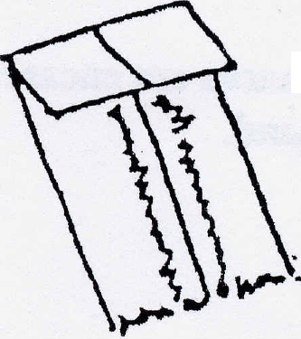
PLAIN SEAM - Place right sides of fabric together and stitch on wrong side. Seam allowances opened and pressed flat.

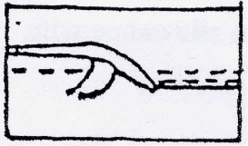
FLAT FELL SEAM - With right sides of fabric together, stitch on the wrong side. Trim one seam allowance to ¼" and fold regular seam allowance over cut. Lay flat against garment and top stitch.

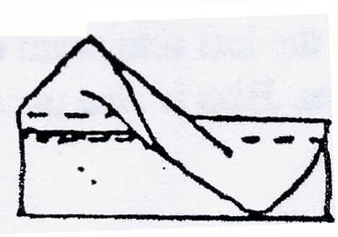
FRENCH SEAM - With wrong sides together, make a ¼" seam. Turn fabric so that right sides are touching and stitch 3/8" from folded edge.

Seam Finishing

Seams were usually finished so that the seam allowances were over cast in some manner or seam allowances were concealed as in a flat fell or French seam.

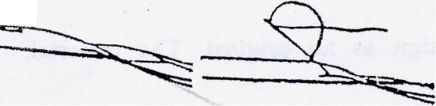
FLAT FELL and FRENCH – Both of these stitches would be done by straight stitch machine or by hand. Examples to the left show a flat fell seam done both by machine and by hand.

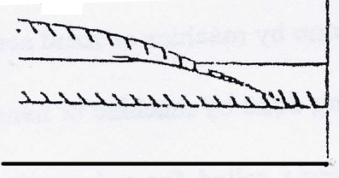
OVERCAST FINISH - Seam allowances finished with thread going up through on side seam allowance and down through the other side of the same seam allowance.

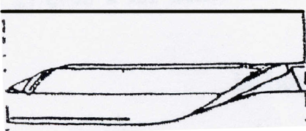
TURNED EDGES - seam allowance edges are folded over onto themselves and stitched either by machine or by hand.

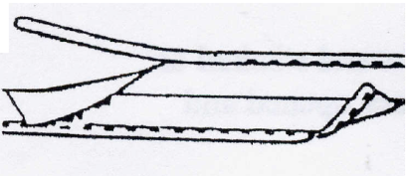
BIAS SEALED EDGES - Edges of seam allowances are encased in bias tape and stitched either by machine or by hand.

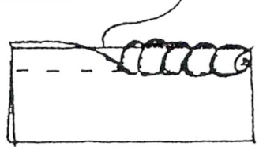
ROLLED EDGES - Make plain seam – roll seam allowance with fingers and overcast.

Plackets and Closings

Most plackets and closings are made with the use of bias strips. Plackets are placed in the left side seam of dresses and skirts. Most plackets in sleeves are placed at the wrist in the underarm seam. Bias is also used to finish necklines and armholes.
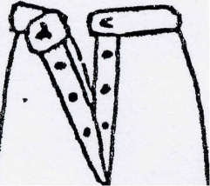
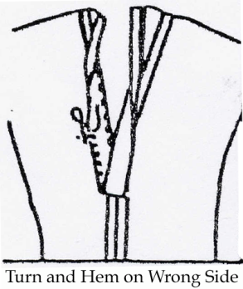
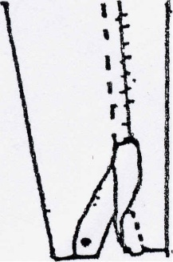
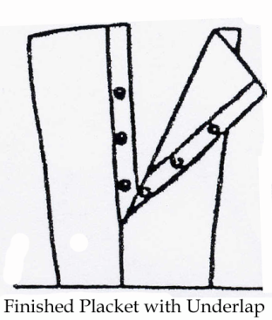

Hems

Hems are usually finished with hand sewing. Some of the heavier materials used for everyday chores were sewn by machine. Examples show: (I) plain hem by hand and by machine; (2) narrow machine hem; (3) circular hem - notice how the fullness is eased in; and (4) rolled hem - this is used in many of the sheer fabrics such as chiffon. Another hem and finish used was the picot edge
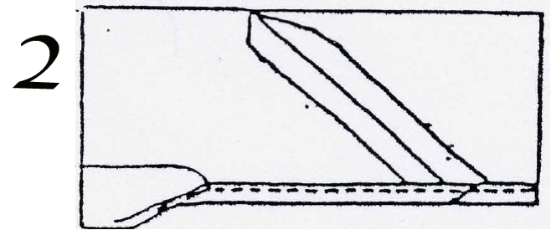
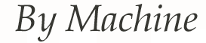
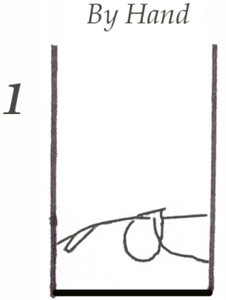
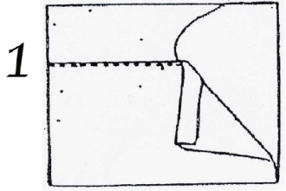

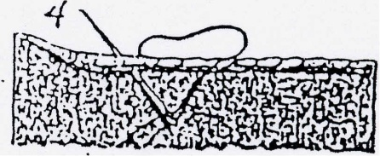
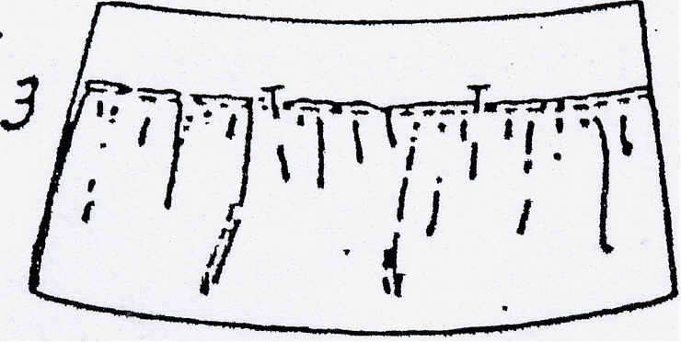

Details and Buttonholes

Most detail work done on the garments was done by hand. Buttonholes were done by hand in most dresses and lighter fabrics while bound buttonholes by machine were made in coats and heavier fabrics. Examples show two styles of buttonholes. Plackets were fastened by hooks and eyes. Bias and cord loops were used for securing buttons. Bias tape was used for finishing most curved areas, such as armholes. Formal sleeve wrist plackets were finished as shown in the illustrations below.
