Fashion Entrant Information
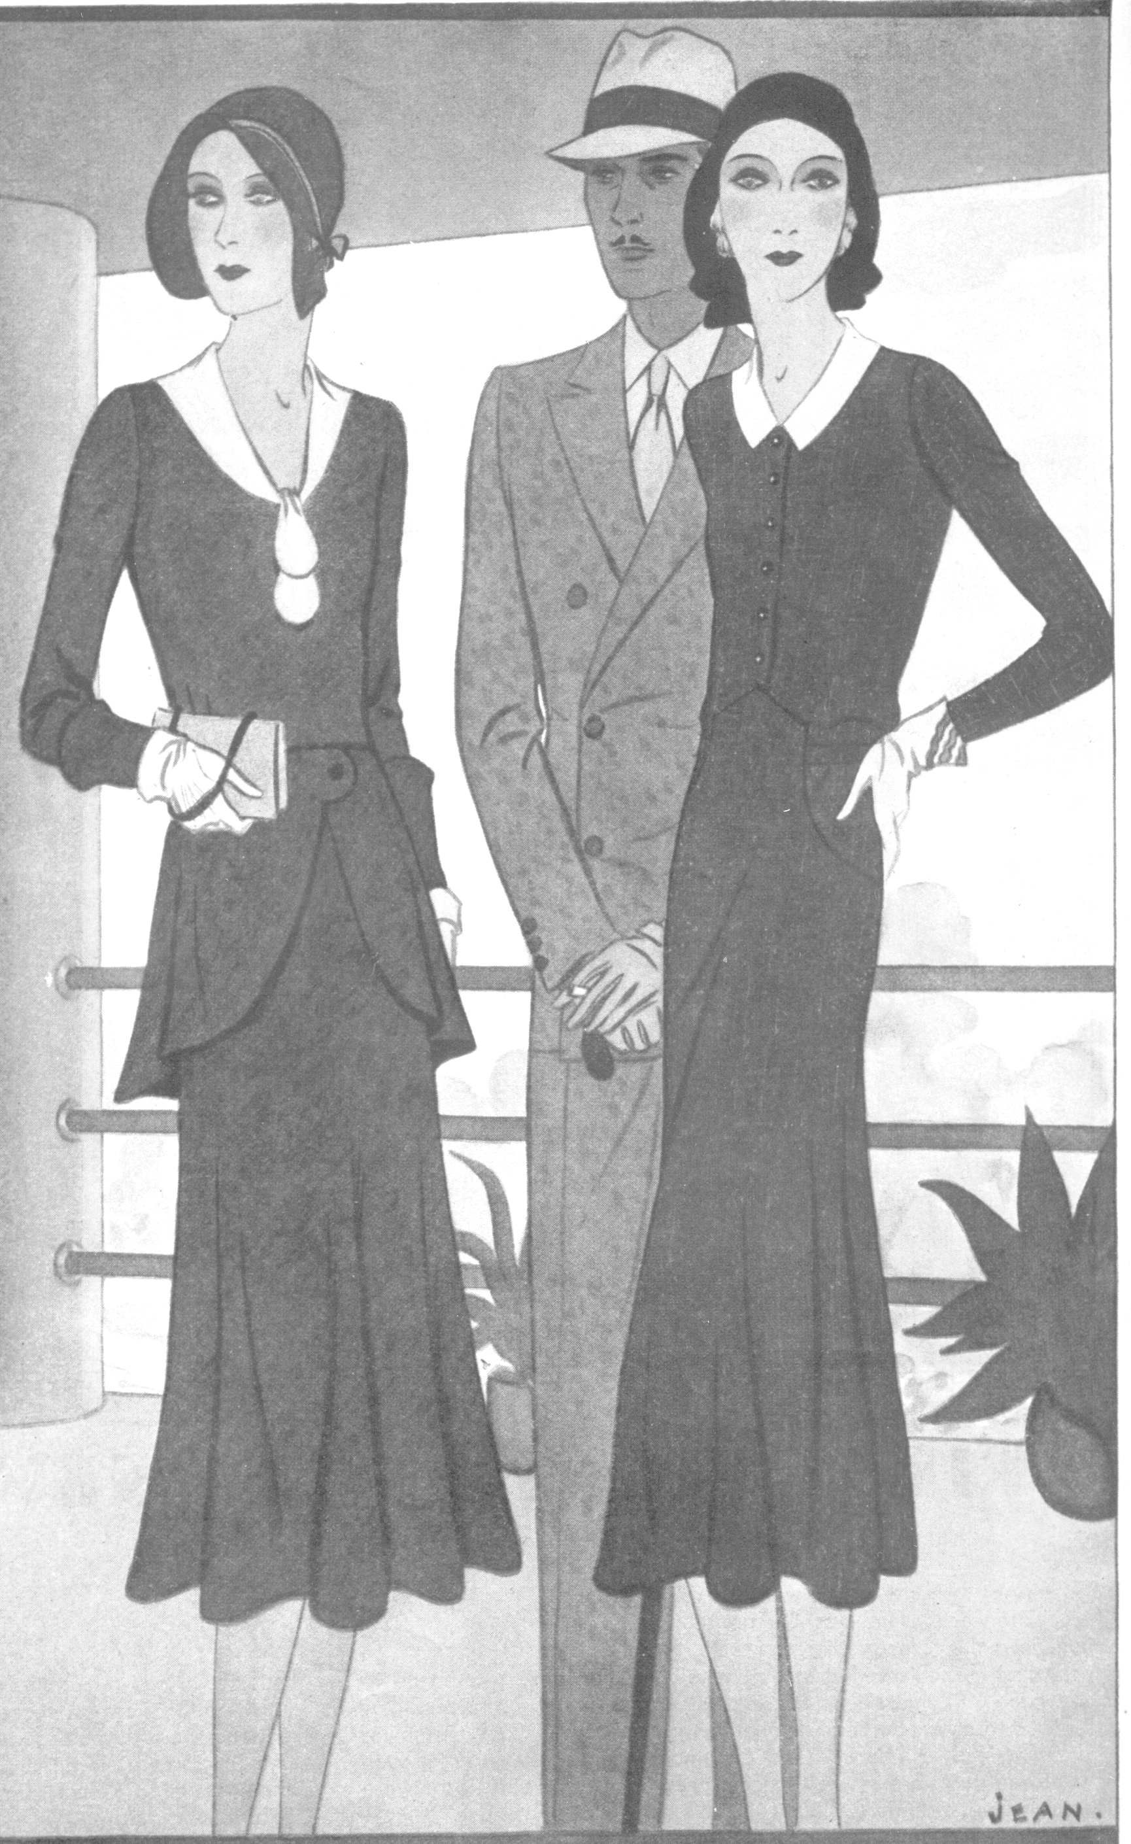

Model A Ford Club of America

Welcome,
We are so glad you have chosen to share your enthusiasm for Model A era fashions. We want you to enjoy your participation in this event. We will aid you in any way we can to make this experience memorable and exciting.
The MAFCA Fashion Guidelines will assist you in understanding fashion judging and become knowledgeable about era fashions and how they are judged, scored and awarded. You can obtain a copy of the Fashion Guidelines from MAFCA Headquarters. The information contained in the Guidelines is comprehensive and well worth the investment.
The Fashion Judging Procedures Manual (FJPM) is also a very helpful resource in preparing you for your experience in fashion judging. The manual is available by downloading from the MAFCA website or you can request a copy by sending an e-mail to fashions@mafca.com, or by regular mail to the MAFCA Headquarters.
There are three categories available for entry. In the Original and Reproduction categories, the major garment determines the appropriate category of the outfit entered in the fashion judging. This does not apply to the Model A Era Image category.
ORIGINAL: Manufactured or made by machine or hand, for wear during 1928-1931. Original fashions are judged for authenticity, appropriateness, condition, fit, completion and coordination of attire and color.
REPRODUCTION: Manufactured or made by machine or hand, after 1931, to represent as closely as possible that which was original. Reproduction fashions are judged on authentic design, fabric, construction, workmanship, condition, appropriateness, completion and coordination of attire and color.
MODEL A ERA IMAGE: The objective of this category is to achieve the look of the Model A era. The entrant may combine current fashions resembling era garments with original or reproduction items, or all current fashion items that have the era look. In this category, fabrics, materials, garment construction and undergarments are not judged. Model A Era Image ensembles are judged on style, condition, fit, appropriateness, and coordination, with the primary focus on the overall appearance.
Fashion awards are based on the Merit System.
- This system gives any and all ensembles the recognition they deserve, regardless of how few or how many individuals have entered. Each ensemble is judged on its own merits and not against other ensembles.
- The awards are based on the number of points received.

150 possible points for Original and Reproduction:
147-150 Award of Excellence
135-146 First Place
120-134 Second Place
0-119 Third Place

100 possible points for Model A Era Image:
98-100 Award of Excellence
90-97 First Place
80-89 Second Place
0-79 Third Place

We look forward to seeing you and your ensemble at the meet.
The MAFCA Era Fashion Committee
Now that you have your fashion entry ready to show, how do you enter fashion judging?
On the meet registration form there is a space to check if you plan to enter fashion judging. Check that space. After the meet registrar has processed your registration, the notification that you are a fashion entrant goes to the meet Host Fashion Coordinator. You will be sent Fashion Judging Entry Forms A & B (copies enclosed in this packet), to complete and return.
Once you have received the forms, fill them out completely. You need to be specific in your description of each area. The judge reads this information to get an idea of what you are going to wear for judging. This information is also used for the fashion show. Be clear in what year (1928-29-30-31) your outfit was worn.
Providing dated documentation is strongly suggested if your item is not represented in the MAFCA Fashion Guidelines. Whenever possible, include a copy of dated documentation on fashion variances with your entry form. (Do not send original materials.) Plan to bring a copy of your documentation into the judging room. (Note: You do not need to bring your original material as long as you have a dated copy.) Acceptable documentation can be a MAFCA publication, era magazines, periodicals, or other era fashion related material providing it is dated from the era. It does not include modern publications from current magazines such as Vogue, Victoria, or Schiffer collector books. Copies including the date, name of the periodical, and the illustrations are acceptable. The judges use the MAFCA Fashion Guidelines as their primary resource.
The MAFCA Fashion Guidelines contains detailed information on each of the five areas of judging, Major Garment (A), Headgear (B), Coordinated Apparel (C), Accessories (D), and Footgear (E). Fill in each area of the Fashion Judging Entry form. Use the “Additional Information” area of the form for supplementary information that is important to the judging of your outfit, e.g., makeup and nails in the style of the era. If more room is needed for any of your descriptions, use the reverse side of the form.
Send your completed entry to the Host Fashion Coordinator of the meet to be received by the entry deadline date indicated on the entry form.
What does the meet Host Fashion Coordinator do with your entry?

The coordinator schedules your judging time and processes your entry form. The notification of your judging time will probably be in your meet registration packet, posted at the meet registration desk, or given to you at the Fashion Entrants Meeting. Should you need a specific judging time contact the meet Host Fashion Coordinator in advance to avoid disappointment, and delays on the actual judging day.
What happens when you are judged?
The judges are MAFCA members, like you, who are interested in era fashions. They have done research and study, learning as much as they can about the fashions of our era. The judges are certified by MAFCA using the process outlined in the MAFCA Fashion Guidelines, Section 1.
In the judging room the judges usually will be seated behind long tables. There may be five or more judges. Generally there are no more than two judges per area. They are assigned for each of the areas to be judged, Major Garment (A), Headgear-Hairdo (B), Coordinated Apparel (C), Accessories (D), and Footgear (E). Although Apprentice Judges may also be participating in the judging process, their scoring will not be part of your judging results.
Arrive at least 10 minutes before your judging time. Photographs will be taken before you are judged. Because each entrant is given individual attention in the judging room, occasionally the judging time is delayed as the process proceeds. Your patience is appreciated. We will keep you informed of any delays whenever possible.
When your scheduled time arrives, you will enter the judging room. You will show your outfit before the judges so they may get an overall picture of you. This aspect is generally done by standing in the center of the room and posing for the judges with a turn or two so they may see the entire “look”.

After you are introduced and the judges have considered your overall appearance, you may be asked to remove your coordinated apparel, gloves and carried accessories. These items will be given to the appropriate judges for their review while your major garment is being judged. You will then go to each area station for closer inspection and maybe a few questions. Each area is generally posted in front of the judges.
The judges are friendly and will do their best to make you comfortable. The room is kept private, for your comfort and to avoid any interruptions. Remember, you are judged individually, not against other entrants.
Any further instructions and time schedules for the fashion show or an entrants meeting will be given to you in advance. Make this a fun experience. Relax and enjoy yourself. Meet new people with your interest in fashion.

The Fashion Judging Worksheet

This segment is designed to give you an idea of what the judges are looking for when you are being judged. In all five areas, items are judged as Original, Reproduction or Model A Era Image. Remember that in the Original and Reproduction categories, your major garment determines the judging category.

Overall Appearance

This area is very important. Ties in scoring are often broken in this area. It is an excellent way to recognize entrants who have gone the “extra mile” to look as if they have stepped out of the Model A era. Have you done your makeup in era fashion? Are your fingernails painted as was fashionable in the era? Is your hair styled in era fashion even if you are wearing a hat? Are your sideburns correct for the era? Do you look like you are part of the Model A era from head to toe? Have you completed your outfit with a hat when needed? If you have chosen the Model A Era Image category, the overall appearance has a greater impact on your score since the emphasis is on achieving the look of the Model A era.

Major Garment (Area A)

In the Original and Reproduction categories, the category in which you are scored is determined by your major garment. In the Model A Era Image category you will not be judged on the type of fabric or the garment construction.

Condition: The condition of the major garment is judged on the type of fabric used, workmanship, and style in the Reproduction category. It is important to insure, on any garment, there are no loose threads, open seams, and the garment or garments are in good repair, cleaned, and pressed. You may be asked to hold up your arms to check for holes or damage, or you may be asked to show a seam. Is mending done neatly?

Fit: Does the garment fit you? Is it too tight? Is it too big? Is it the correct length?

Appropriateness: Is the garment appropriate for your age? Is it appropriate for the division you have entered, i.e. afternoon, evening, sport, or daytime?

Headgear/Hairdo (Area B)

Hat
Condition: Is the hat clean and in good repair?

Fit: Does the hat fit your head? Are you wearing it properly?

Hair Showing: Is the hair supposed to show? If so, is it in the style of the Model A era?

Coordination: Does the hat go with the outfit?

Appropriateness: Is the hat appropriate to your age group? Is it appropriate for the season and the time of day your outfit would be worn? Is it correct for the year of the outfit? Have you completed your outfit with a hat when needed?

Hairdo Only (If no hat required)

Some ensembles, especially evening wear and loungewear, did not always require a hat. If your outfit does not require a hat, you will be judged on your hairstyle.

Style: Is your hair fashioned in the style of the era and the year?

Appropriateness: Is the style appropriate for your outfit and your age?

Hairdo with Adornments

The style of the hairdo is judged under Original, Reproduction or Model A Era Image as indicated on the form in this area. The adornment is judged as Original, Reproduction or Model A Era Image.

Condition-Adornment: What is the condition of the adornment? Are the stones all there, and is it polished?

Coordinated-Adornment: Is the adornment coordinated with the outfit?

Appropriate-Adornment: Is the adornment appropriate for the outfit and the age of the entrant?

Coordinated Apparel (Area C)

Undergarments and outer garments are judged separately, as Original, Reproduction or Model A Era Image. The judging of undergarments is done in the most discreet and respectful manner. The judges are conscious of your privacy and modesty. If you are a female, you will be asked to show a small portion of your undergarments. For example, the fabric, construction, and condition of your slip or teddy can be determined by a slight lift of your major garment hem above your knee. Your slip or bandeau strap can be observed at the shoulder. It is acceptable for an entrant to wear a modern bra in the Original and Reproduction categories.

If you are a male, you will be asked to unbutton a single shirt button to show the fabric of your undershirt or union suit. If you are wearing briefs you will be asked to show a small portion of the waistband. As with the other areas, the item is judged as Original or Reproduction, along with condition and appropriateness. Fit is not judged in undergarments to insure your comfort.

In the Original and Reproduction categories, if you choose not to have your undergarments judged, the point loss will be 7 points. Undergarments are not judged in the Model A Era Image category.
For outer garments, the item is judged for fit, condition, and appropriateness. As with the other areas, does the garment fit you, is it in good repair, and is it appropriate to the outfit and your age? You will be asked to put on your outer garment to check for fit.

Accessories (Area D)

In this area judges are looking for not more than three accessories which help to complete the ensemble. The exception to this is for the Children’s class, where only two accessories are required. There is a list of suggested accessories in the MAFCA Fashion Guidelines, Section 1. Should you bring more than the required number of accessories you will be asked to choose which ones you would like to have judged. It’s helpful if you make this decision while you are putting your outfit together. Remember, condition, coordination, and appropriateness will be considered as the item is judged. Keep in mind; if you have entered in the Original or Reproduction category, the items need to align with that judging category.

Footgear (Area E)

In this area, shoes, hosiery and garters are judged. In all categories pantyhose may be worn under original hosiery, for the purpose of protecting the hosiery.

Condition: Are the shoes in good repair? Is the hosiery without runs or holes?

Fit: Does the shoe fit your foot? Does the hosiery fit correctly?

Coordination: Do the shoes and hosiery go with the outfit?

Appropriateness: Are the shoes right for the time of day? Is the hosiery consistent with the function of the major garment, e.g., cotton with a housedress, silk with an evening dress?

Best Wishes for an Enjoyable Fashion Experience

MAFCA FASHION JUDGING ENTRY FORM (A)

Registration Number ________________________ Entry Deadline ________________________
Entrant Name______________________________ Phone _______________________________
Address __________________________________ Email _______________________________
City _____________________________________ State _________ Zip code _____________
Return entry form to: ________________________________________________________________
__________________________________________________________________________________

Circle below all that apply:
Category: Original Reproduction Model A Era Image Year______
Division: Daytime Active Sports Specialty Formal
Class: Children Junior Family Group Couple Men Women
(0-12) (13-18)
____________________________________________________________________________________________________
The major garment determines the category to be judged in Original and Reproduction. Each individual must fill out a separate entry form. If entering as family, group or couple you must be attired similarly for the category and division. Entrants are allowed only one ensemble to be judged. If in doubt as to division, leave blank, but fully describe the ensemble.
Be prepared for questions and a closer inspection by the judges. Now would be a good time to think about documentation. Be clear as to what year (1928-1931) your outfit was worn. Anything that does not resemble an item pictured in the MAFCA Fashion Guidelines, may require you to provide further documentation. Acceptable documentation can be from MAFCA publications and the MAFCA website fashion articles. Also magazines, periodicals, catalogs or other era fashion related material providing it is dated 1928-1931, may be used. Not acceptable are modern publications from current magazines such as Vogue, Victoria, Schiffer and other collector books, as information in these publications is not always specific enough to the year in which the item was manufactured. Copies of your documentation are acceptable but must include the date, name of the periodical, and illustrations. Providing dated documentation is strongly suggested if your item is not represented in the MAFCA Fashion Guidelines. Bring copies of your documentation to the judging room. The judges use the MAFCA Fashion Guidelines as their primary resource.
The Chief Judge, or person assigned, reserves the right to properly place entrant in correct category, division, and class. Original ensembles should be all original or as complete as possible. Model A Era Image ensembles are to represent the styles of the era and should be as complete as possible.
Incorrect category items will result in an appropriate reduction of points; for example, reproduction items worn or carried with an original ensemble or original items worn or carried with a reproduction ensemble.
Questions, comments, or suggestions regarding the judging results are to be directed to the Era Fashion Committee Chairperson.
___________________________________________________________________________________________________
I hereby release and hold harmless MAFCA and individual members of this organization from any and all liability occasioned by my participation in the above named event. I agree to abide by the procedures outlined in the MAFCA Fashion Guidelines. I understand the decision of the judges is final. Signature is required on all entries. Each entrant must be a MAFCA member.

______________________________________________ ____________________________________________
Print Name Signature

MAFCA FASHION JUDGING ENTRY FORM (B)

Registration No. Entry Deadline

Entrant Name

Year: (circle one) 1928 1929 1930 1931
Category: (circle one) Original Reproduction Model A Era Image
Print or Type Description

A. Major Garment:

B. Headgear/Hairdo:

C. Coordinated Apparel:

D. Accessories:

E. Footgear:

Additional Information:

If more room is needed for descriptions, please use another sheet of paper or the reverse side of this form. Bring dated documentation if any item being judged is not pictured or described in the MAFCA Fashion Guidelines.
MAFCA FASHION JUDGING ENTRY FORM (B) (Sample)

Registration No. Your registration number Entry Deadline (Provided)

Entrant Name Sally Mae Smith

Year: (circle one) 1928 1929 1930 1931
Category: (circle one) Original Reproduction Model A Era Image
Print or Type Description

A. Major Garment: Late afternoon blue and tan chiffon dress with a bertha collar and uneven

hemline, it also has an attached slip. The dress is finished with picot edging.

Similar to Fashion Guidelines page 3A-23, item H.

B. Headgear/Hairdo: Hair styled in finger waves with a rhinestone hair clip.

See Fashion Guidelines page 3B-16 for similar hair clip.

C. Coordinated Apparel: Outer garments – Blue - silk fringed shawl (See FG 3C-21)

Blue silk wrist length gloves with 3 gores. (Undergarment) Peach silk bandeau with matching

step-ins. (See FG 3C-35 for style of undergarments.)

D. Accessories: Clear crystal 2 strand necklace with matching silver and crystal drop earrings

with screw backs. Whiting and Davis blue and tan enameled mesh purse and a silver compact.

E. Footgear: Blue satin T-strap pump with a spike heel, seamed silk stockings with round

garters. (see attached copy of Delineator, January 1929, page 47)

F. Addition information: Hair and nails done in era fashion.

If more room is needed for descriptions, please use another sheet of paper or the reverse side of this form. Bring dated documentation if any item being judged is not pictured or described in the MAFCA Fashion Guidelines.

